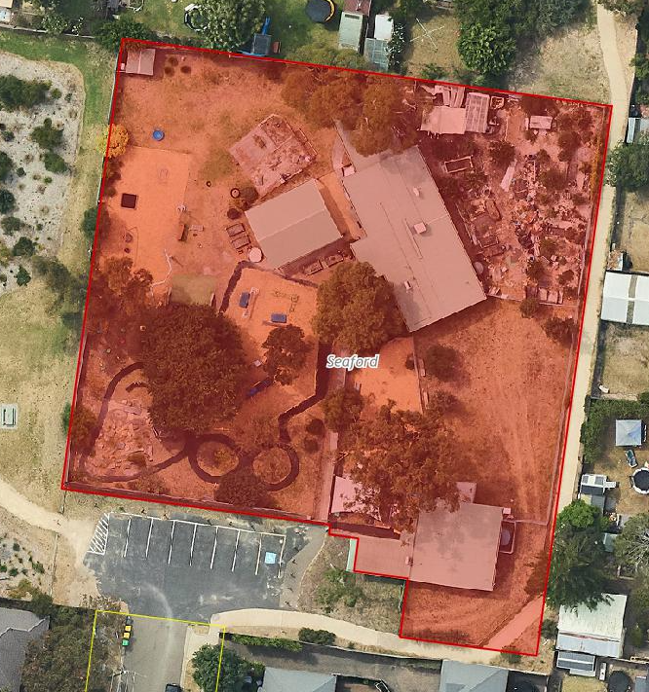

**Outdoor play space**

**Kindergarten**

**Playgroup building**

**Food forest**