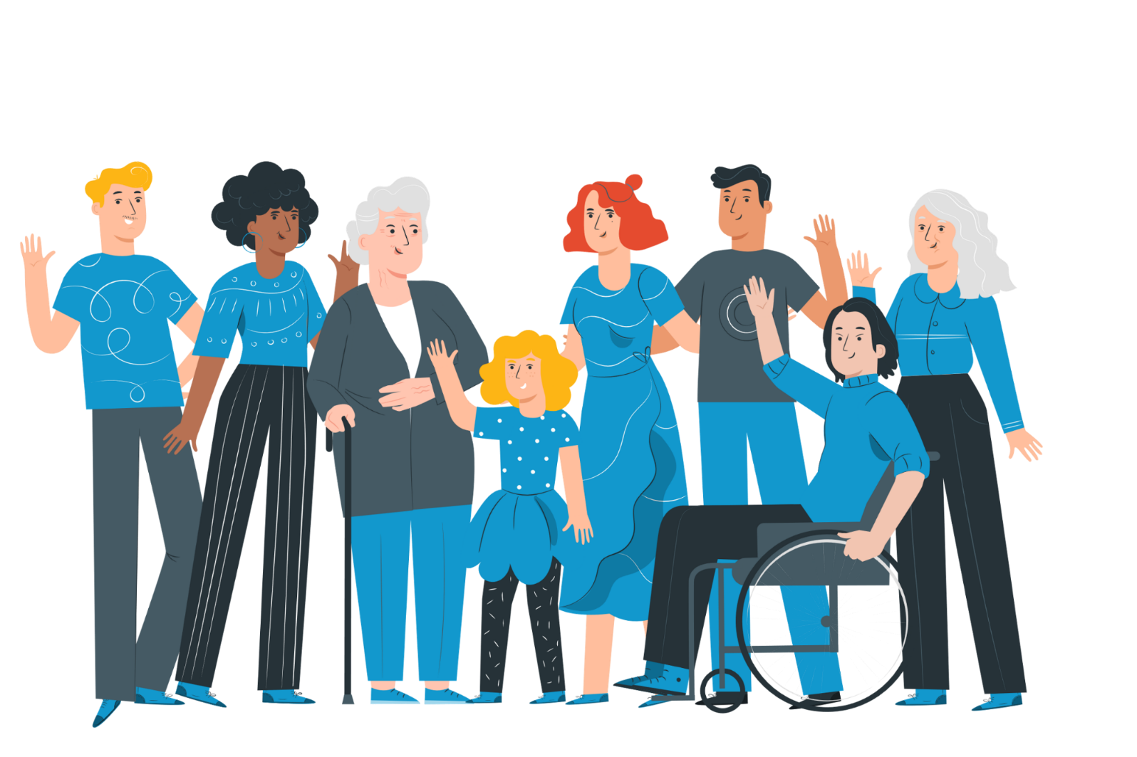

Engagement Report
Draft 2022-2026 Budget (including 2022-2023 Council Plan Initiatives)

Consultation highlights 3
Key engagement statistics 3
Barriers to engagement 3
Overview 4
Purpose 5
Objectives 5
Community consultation process 5
Council consultation process 5
Consultation materials 5
Community pop-ups 5
Online 5
Community feedback 6
Stakeholder feedback 7
Council feedback 7
Recommendations 9
Next steps 9

Consultation highlights
The consultation was undertaken by Frankston City Council to inform the development of the Draft 2022-2026 Budget (including 2022-2023 Council Plan initiatives).
The consultation period ran from the 27th April until the 24th May 2022. Engagement pop up stations were set up at various locations throughout the Frankston community.
Submissions received from 21 community members online, and 4 in-person submissions at Council’s public Hearing of Submission Meeting informed the Frankston City Council Draft 2022-2026 Budget (including 2022-2023 Council Plan Initiatives).
Particular highlights included:
- Significant feedback relating to Community Support Frankston (CSF), due to multiple concerns about their funding and support for programs. As a result, Council has agreed to re-evaluate the budget for the CSF program and consider additional funding mid-way through the financial year.
- Seaford Market was the most successful location to engage with the community throughout all of our engagement dates and locations throughout this engagement period.
- Feedback provided from the Kananook Creek Association and the new members was high due to significant changes in the board members, who also attended Seaford Market event.

Key engagement statistics
Council undertook an open community engagement program in 2022 on the Draft 2022-2026 Budget (including 2022-2023 Council Plan Initiatives), that followed deliberative engagement on the initial Council Plan development in 2021..
In addition a range of community engagement activities assisted to shape the development and final decision making for the Council Plan and Budget in 2022, including Major Initiatives, including:
- Online Survey and Polls
- Facebook, Linked in
- Community Pop-ups
- Submissions during public exhibition
Initially Council had organised 6 engagement pop ups and 1 was cancelled due to inclement weather.
Residents throughout the engagement viewed the online portal 941 times with 559 visits to the engagement portal.
21 contributions were made during the engagement period with the highest peak time for views on 3 May 2022.

Barriers to engagement
During community consultations, there are often limitations to the engagement overall and/or specific engagement activities. The limitations of this consultation have been identified as:

Weather
Only one engagement event was cancelled due to inclement weather on Saturday 7 May. The state of weather on the day and time of other community pop-ups had a minor impact on the amount of people who were at the location at the time of the events.

COVID-19
All engagements were completed face to face but found that COVID did not implicate the pop ups and the amount of residents who attended..

Timing in an election campaign
There were lower than expected numbers of community members attending engagement pops ups, with the exception of Seaford Market. This could be due to the timing of this engagement in a Federal election campaign, which may have added a barrier to residents attending and providing feedback.

Overview
Frankston City Council drafted this year’s review of their Draft 2022-2026 Budget (including 2022-2023 Council Plan initiatives) for consultation. This year Council has drafted its largest capital works program to build Frankston’s future and revitalisation initiatives to include Destination Events Program.
The budget has focused and prioritised across many services including sports & recreation, biodiversity and open space, car parking, transport and connectivity, arts and culture and events; in addition a focus on delivering a successful Climate and sustainability plan for Frankston’s future.
To meet Local Government Act 2020 requirements, key principles need to be considered regarding governance, deliberative community engagement, public transparency, strategic planning, financial management and service performance.
Council undertook community engagement as prescribed by the new Local Government requirements, and took place over 4 weeks throughout the community at various engagement locations.

Purpose

Frankston City Council seeks to develop and adopt the Draft 2022-2026 Budget (including 2022-2023 Council Plan initiatives) that sets the strategic direction for Council over the next year with consideration to the needs and aspirations of the community.

Objectives

The objective of this year’s Council Plan and Budget engagement process was to seek input from the community to inform the balance of essential services with future innovation and development. We have learnt from the challenges of the past two years while also moving forward – working between the importance of community relief with the need for economic, city growth and infrastructure development.

Community consultation process

The community engagement process was undertaken over a 4 week period from the April 2022 to May 2022.

Consultation materials

To help inform the Council staff and community, a number of engagement materials were developed to promote the Draft 2022-2026 Budget (including 2022-2023 Council Plan initiatives). Posters were created to support in-person consultation activities. The posters were displayed at community consultation events and online as conversation starters.

The seven posters included:

- Council Plan and Budget Poster – Consultation timeline
- Six Outcome posters with Draft Budget

These posters have been provided in Appendix A.

Community pop-ups

Frankston City Council ran five public pop-ups to consult the Frankston community on the Draft Council Plan and Budget 2022-2023 initiatives (one more pop-up was scheduled but cancelled due to inclement weather). The locations and times of the pop-ups were strategically chosen to reach large numbers of residents and harder to reach groups.

The pop-up locations and times are displayed below.

Pop-up locations | Date | Time
Excelsior drive shopping strip | Wednesday May 4th | 1130am-130pm
Little Beauty Market | Saturday May 7th | 10am–1pm  Cancelled due to weather
Gateway Shopping Centre | Wednesday 11th May | 1130am-130pm
Foot Street shopping strip | Friday 13th May | 1130am-130pm
Seaford Farmers Market Seaford | Sunday 15th May | 10am-1pm
Carrum Downs Shopping Centre | Thursday 19th May | 1130am-130pm

Online
Throughout the engagement period, online engagement was promoted through several social media platforms to ensure participation in an online survey as part of the submission process on Engage Frankston.

Online Survey

An online survey was provided for feedback around Council’s Draft 2022-2026 Budget (including 2022-2023 Council Plan initiatives) on Engage Frankston.

The survey was open between 27 April - 24 May and sought feedback on the Draft to inform the prioritisation for funding in the draft Budget and initiatives for Council.

Social Media
The consultation was promoted on Facebook and LinkedIn.

Community feedback
Residents throughout the engagement viewed the online portal 941 times with 559 visits to the Engage Frankston page.
Council received 21 submissions/feedback from our engagement consultation process. Below displays the submissions and the feedback provided from all 21 submissions.
A majority of the submissions related to the Community Support Frankston Program and advocacy for current and future funding to be considered, toy library and emergency relief. In addition there were 4 in person submissions presented at Council related to Kananook Creek, permits for winter shelters and an education hub for the Indigenous Garden.

Positive insights
Positive support for the Community Support Frankston and what great work they have provided throughout COVID and post COVID. There was one submission in support for the Toy Library and one for additional funding around Emergency Relief.

Opportunities for improvement
Although sentiment results had some positive feedback for the Community Support Frankston Program as a whole, the majority of feedback resulted in requesting additional funding and resourcing for the program. As a result, Council has agreed to re-evaluate the budget for the CSF program and consider additional funding mid-way through the financial year.

Key learnings
What worked
The Seaford Market was a great opportunity to receive consultation and feedback from the community with a variety of residents gathering to support the community.

Not working so well
Engagement pops up were lacking in community engagement presence at most of the locations with the exception of Seaford Market; this could be due to the timing of this engagement in a Federal election campaign, that could have placed a barrier for residents to provide feedback at the locations of each engagement event.

There would be benefit in seeking community input earlier in the Budget process to ensure ideas and priorities can shape the development of the Draft Budget.

Stakeholder feedback
Stakeholder engagement included a Councillor Planning day along with Executive and officer participation to provide information to Councillors if needed. Feedback from the planning day was received and overwhelmingly positive from the Councillor and Executive Team.

Council feedback
Councillor feedback was provided through EMT at various times prior to the engagement and the draft period with positive results about the Councillor Planning Day on Saturday April 2nd and revised Budget Process.

The Engagement Plan for this consultation included several measures of success related to the engagement objectives.

The success measures met and the objective they relate to are outlined below:

Objective | Success Measure
Inform community of Annual Budget, particularly new operation initiatives, and new actions on delivery Council Plan priorities. | Seek feedback online,  “Have we got it right”  Achieved – 941 views to the Engage Frankston page; 21 submissions received online.

Council’s commitment to undertake this consultation has been positively received by the Frankston community. Although Council intended to drive more participants and submissions we understood the current political climate during the consultation period. It is clear many individuals value the opportunity to be increasingly part of Council’s decision-making processes and have their voices heard on a variety of topics, including financial management and forecasting.

Recommendations
Based on the feedback received from the engagement process, the recommendations are as follows.

- Council to consider increasing the budget for CSF (Community Support Frankston) in current and future years to include allocation of resources
- Support for the Toy Library
- Support for increasing funding for emergency relief
- Kananook Creek
- Holy Family renovations
- Emergency Relief
- Education Hub for Indigenous gardens
- Arts & Culture Strategy
Council’s Community Engagement Team has also recommended that there would be greater benefit in seeking community input earlier in the Budget process to ensure ideas and priorities can shape the development of the Draft Budget.

Next steps

Council wishes to acknowledge and express gratitude to all the members of the community who have participated in engagement activities informing the Draft 2022-2026 Budget (including 2022-2023 Council Plan initiatives).

The final Draft 2022-2026 Budget (including 2022-2023 Council Plan initiatives) was adopted by Council on 30 May 2022.

Consultation materials

Engagement poster’s – Council Plan and Budget Poster – Consultation timeline

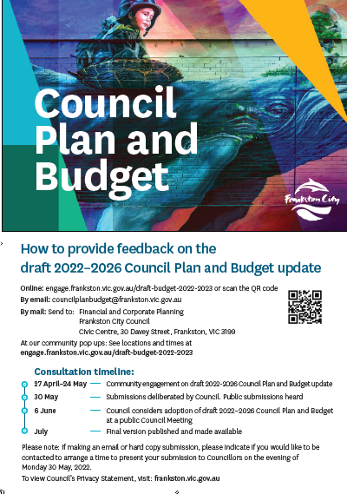

Engagement poster’s – outcomes

