Asset Management Policy
A4911531

Policy Statement
Frankston City Council is committed to ensuring that all Council assets are appropriately managed and relevant to community needs. This Policy is intended to:
  - Establish a framework to ensure that asset management is undertaken in a structured, coordinated, cost effective and financially sustainable manner;
  - Guide the ongoing review and update of Council’s Asset Management Strategy, Asset Plan, Service and Asset Management Plans;
  - Ensure Council budgets provide the appropriate level of non-discretionary funding for renewal, maintenance and operation of existing assets ahead of discretionary funding for new assets and asset upgrades to ensure ongoing provision of existing levels of services; and
  - Guide Council’s decision making with respect to Life Cycle Costing, the Long-Term Infrastructure Plan (LTIP), Financial Plan, Service Planning and Annual Budgets.

Reason for Policy
A key function of this Policy to define the Asset Management Framework that will be used to guide Council in the planning and investment in community assets (refer Figure 1).
Frankston City Council has responsibility for the stewardship of assets for the benefit of current and future generations. The most recent valuation of Council’s asset portfolio was $2.09B (2021/22 Financial Report). Millions of dollars are spent annually managing and maintaining these assets. It is therefore important that Council employs sound asset management practices to ensure all Council assets are managed effectively and sustainably.
Implementation of the Policy is expected to achieve the following asset management objectives:
  - Council assets are well managed throughout their lifecycle;
  - Council will manage its asset portfolio in a manner that ensures its compliance to the relevant legislation and regulations;
  - Council assets support triple bottom line outcomes of environmental, financial and social sustainability;
  - Asset management decisions are based on an integrated process, which includes community participation, has a long term focus, and balances competing social, financial and environmental priorities;
  - Council is accountable for its asset performance and its asset management activities;
  - Non-discretionary funding for the maintenance, operation and renewal of existing assets is prioritised ahead of discretionary funding of new, upgrade and expansion of assets;
  - Council proactively inspects and protects its asset inventory and will seek to recover the cost for reinstating damages from the responsible third parties;
  - Council increases facility utilisation by reducing the current asset stock and the development of integrated multi-purpose facility hubs;
  - Council’s exposure to risk and litigation is reduced, in regard to asset failures, property risk exposure, damage and loss; and,
  - Council will continue to improve its knowledge and asset management practices (including staff training and competencies).

Scope
This Policy is established on:
- A set of Policy statements aligned to organisational objectives that reflect overall asset management approach
- A specific set of asset management principles
This Policy provides the guiding principles for long-term sustainable management of Council’s asset portfolio. The Policy defines the asset management framework which has been developed based on industry best practice guidelines such as the ISO 55000 asset management system requirements.
This Policy is applicable to all Council owned assets and all Council-managed assets (including leased assets) that:
  - are used by the community;
  - support the delivery of services provided for the benefit of the Frankston community; or
  - are held by Council for future use
This Policy applies to all Councillors and Council officers involved in the acquisition, operation maintenance, upgrade, renewal and rationalisation of Council assets. The Policy applies to all contracts applicable in these areas. It also applies to all officers responsible for the delivery of services that make use of Council assets.

Authorisation
This Policy is managed by the Sustainable Assets Department, and is approved by Frankston City’s Mayor and Council’s Chief Executive Officer (CEO):

--------------------------------------- ----------------------------------------
Mayor, Frankston City CEO, Frankston City Council
in accordance with Frankston City Council resolution at its Ordinary Council meeting of dd Sept, 2023.

Revision date
This Policy will be reviewed and presented to Council no later than June 30, 2027 or earlier as deemed necessary by Council, and therefore once within each subsequent Council term.

Principles
This Policy is expected to deliver the following vision for asset management practices:
As stewards of community assets, Frankston City Council will provide assets that support the provision of best value services. Council assets will be accessible, safe and suitable for community use. The approach to asset management will be sustainable. It will balance competing community social, environmental and economic needs for the benefit of current and future generations.
To realise Council’s vision and to meet increasing service delivery demands requires a functional and cost effective asset base. To achieve this, an integrated and multi-disciplinary approach to asset management is necessary.
Achieving best value in relation to both short and long-term service needs requires an understanding of the total costs associated with each asset over its lifecycle (from creation to disposal). Adopting a best practice approach to asset management will enable Council to safeguard the considerable investment required to sustain its asset portfolio for current and future generations.
This Policy is based on a set of guiding asset management principles. All asset management decisions will be guided by the following principles:
  - Ensure Assets Support the Services Provided by Council;
  - Community Involvement in Decision-Making;
  - Focus on Long-Term Sustainability;
  - Sustainable Investment in Capital Works;
  - Continuous Improvement in Data and Asset Management Information Systems;
  - Compliant Asset Accounting;
  - Legislative and Regulatory Compliance;
  - Compliance with Insurance Obligations;
  - Continuous Improvement in Risk Management;
  - On-going Training and Skill Development; and
  - Effective Performance Monitoring and Reporting.
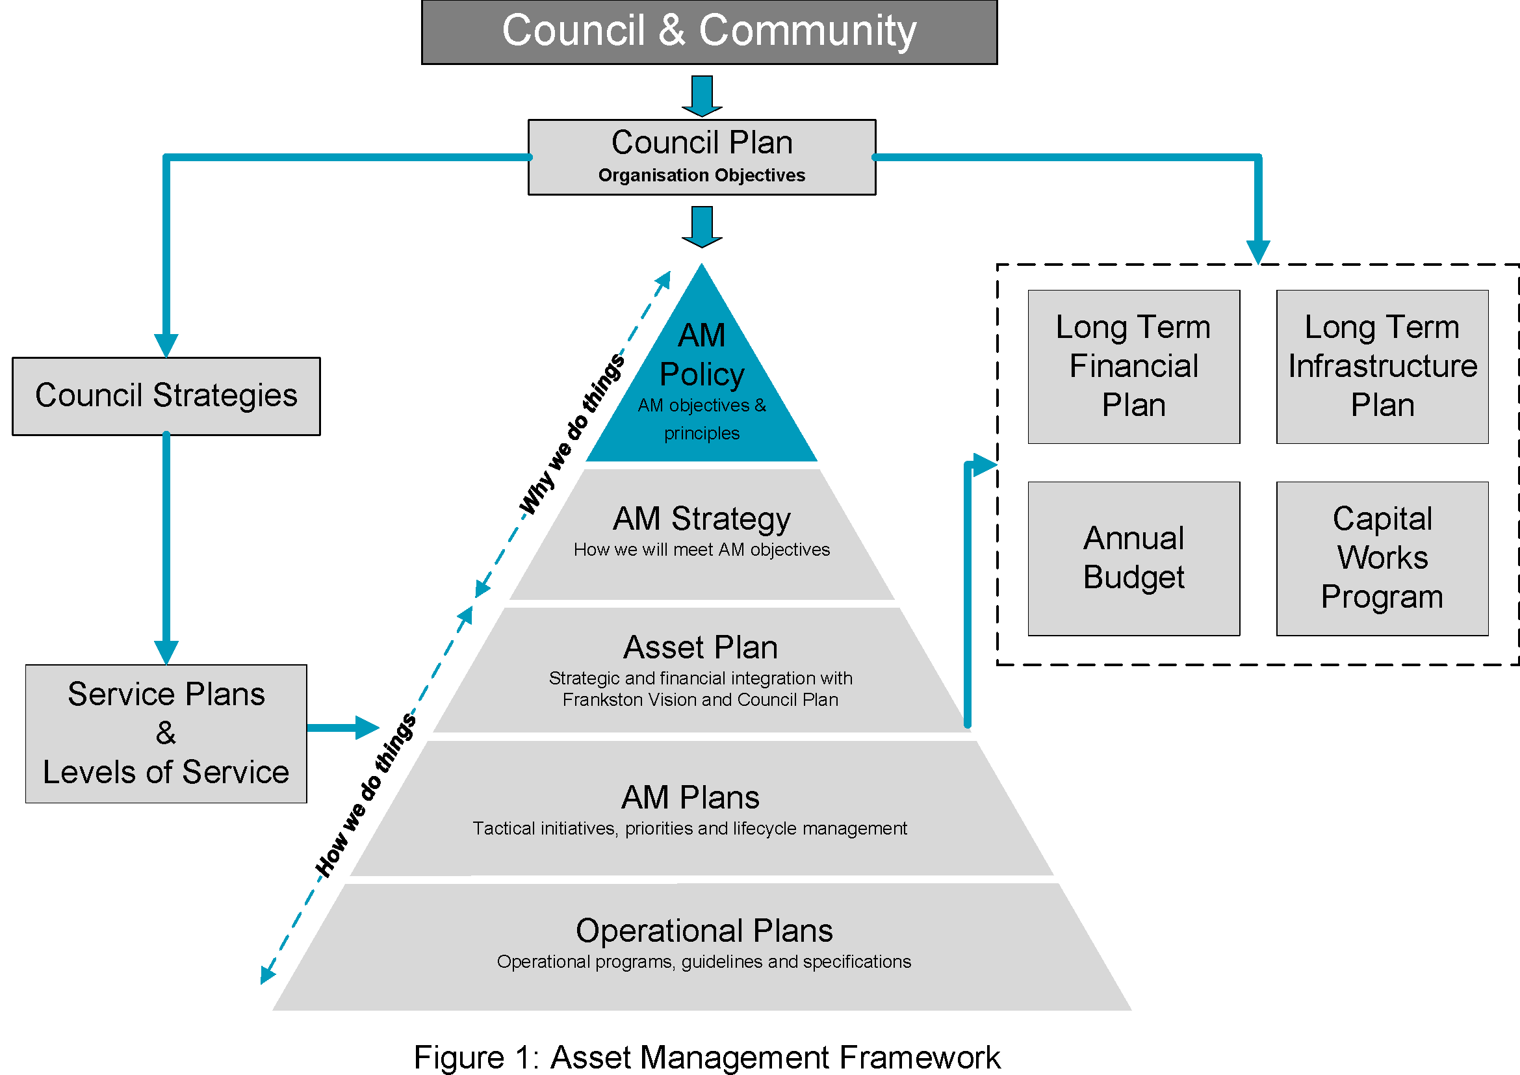

Roles and Responsibilities
This Asset Management Policy will be adopted and implemented through the Strategic Asset Management Governance Structure to ensure integration of asset management planning and service delivery.
The roles and responsibilities of the Strategic Asset Management Governance Structure is defined as below:
  - Council:
    - Act as custodians and stewards of community assets.
    - Be aware of best practice asset management principles.
    - Ensure commitment to sustainable asset management principles is incorporated in the Council Plan.
    - Ensure that legal and statutory compliance obligations are met.
    - Approve organisational objectives, Asset Management Policy, Strategy and Plans.
    - Approve the alteration and/or rationalisation of under-utilised or surplus Council assets.
    - Ensure appropriate financial resources for non-discretionary asset management activities are maintained in accordance with funding strategies of the Financial Plan & LTIP.
    - Establishment of service provision to balance community expectations and affordability.
  - Executive Management Team:
    - Act as the principle advocates (leadership) of community assets and establish organisational plans and objectives.
    - Ensure that legal and statutory compliance obligations are met.
    - Take overall responsibility for implementing the organisation’s objectives, Asset Management Policy, Strategy and Plans with agreed resources.
    - Facilitate the effective operation of Council’s Strategic Asset Management Team (SAMT).
    - Supports asset management requirements in relevant staff position descriptions and performance plans, and provide asset management learning and development programs.
    - Ensure that accurate and reliable information is presented to Council for decision-making.
    - Promote cross-functional collaboration and the importance of sustainable asset management practices within the organisation.
    - Ensure that Councillors and staff are adequately trained and skilled in sustainable financial, environmental and asset management practices.
  - Strategic Asset Management Team:
    - Have a broad understanding of asset management issues and the continuous improvement approach being adopted.
    - Monitor and report the delivery of the Asset Management Policy, Strategy, Plans and improvement actions to EMT.
    - Review and implement, where possible, external audit recommendations relating to asset management.
    - Raises awareness throughout the organisation of the benefits of committing to a strategic asset management approach.
    - Identify opportunities and support development for improvement in relation to the planning, development and management of assets.
    - Advocate for improved strategic asset management outcomes.
    - Recommends budget allocations for renewal expenditure as per Council’s Financial Plan & LTIP.
    - Approves forward schedule of asset audits and AM Plan reviews.
  - Asset Managers and staff
    - Implement the Asset Management Policy, Asset Plan, Asset Management Strategy and Asset Management Plans.
    - Manage municipal assets in consideration of long term sustainability.
    - Develop and implement tactical and operational plans (such as maintenance programs, capital works programs) in accordance with the relevant Asset Management Plan and works management plans.
    - Establish service delivery needs and define service levels in consultation with local community stakeholders, and balances competing social, financial and environmental priorities.
    - Ensure that appropriate infrastructure is provided and maintained to meet service delivery needs.
    - Development of levels of service, KPIs and service delivery to agreed risk and cost standards.
    - Ensure an asset options evaluation process is undertaken whenever an asset is no longer required to support the current service.
    - Prepare State of Assets Report and Asset Management Improvement Action Status Report and performance reporting against levels of service and KPIs.
    - Adhere to SAMT initiatives.
    - Ensures municipal assets are compliant with relevant legislation and regulations.
    - Supports Council to be responsive to changes in legislation and regulations and provide appropriate funding to ensure compliance occurs in a timely manner.
    - Oversees the maintenance of road related assets to ensure ongoing compliance with the Road Management Plan.
    - Ensures the valuation of Council assets will be in accordance with the accounting standards applicable for local governments within the State of Victoria.
    - Monitors compliance with insurance obligations and ensures information regarding asset valuations and insurance replacement values are linked to the asset register.

Policy non-compliance
Failure to comply with this Policy is likely to result in increased risk of:
  - Unsafe infrastructure;
  - Assets that are not fit for purpose;
  - Assets that do not adhere to with Council’s social, environmental and economic priorities;
  - Assets with excessive on-going operational costs;
  - Failure to rationalize surplus assets;
  - Underinsured or uninsured assets;
  - Damage to private property;
  - Service disruption;
  - An increase in the renewal gap;
  - Failure to comply with statutory reporting requirements; or,
  - Performance management for staff who fail to adhere to the Policy

Related documents
The Council Plan 2021-2025 guides the organisation’s overall strategic direction. The Council Plan acknowledges that strategic asset management is essential for effective delivery of community services in a financially responsible manner.
Council’s Strategic Resource Plan and a number of other high-level strategic documents, including this Policy, support the delivery of the strategic objectives set out in the Council Plan.
All revised Asset Management Plans will be adopted by Council and will be informed by community consultation and local government financial reporting frameworks. The Asset Management Plans will incorporate service level targets and include predictive financial modelling that will inform Council’s future Long Term Financial Plan and budgets.
This Policy has been developed in keeping with ISO 55000 standards (2014), the recommendations in the International Infrastructure Management Manual (2015) published by the Institute of Public Works Engineering Australasia (IPWEA), key pieces of legislation, adopted policies of Council and key strategic documents.

Implementation of the Policy
Following adoption of this policy the Strategic Asset Management Team (SAMT) will be responsible for delivery of this Policy required to operate the Asset Management Framework including the Asset Management Strategy, Service and Asset Management Plans.
The SAMT is composed of representatives from all areas of Council and will ensure Council has an integrated approach to continuous improvement in its asset management practices and capabilities.
SAMT will meet regularly and its meetings, and other existing internal communication mediums, will be utilised to explain the key features of this policy to all affected staff.
Implementation of this policy requires the development and adoption of revised Asset Management Strategy, Service Plans and Asset Management Plans guided by the principles outlined in this policy.

Definitions
Asset
An item or entity that has potential value to Council, and for which the Council has a responsibility.
Assets include: infrastructure assets (i.e. roads, footpaths, cycle paths, kerbs and channels, street furniture, signage, street trees, bridges, buildings, drains, playgrounds, open space and sporting reserve infrastructure); cultural assets (i.e. art collections); office equipment (software, desks, computers, etc.); vehicles; plant equipment and associated infrastructure required for the delivery of Council services (which may be non-Council and managed or utilised through a formal agreement).
Asset Management (AM)
The coordinated activities of an organisation to realise lifecycle value from assets in delivery of its objectives.
Asset Management FRAMEWORK
A set of tools – policies, plans and business processes - which guides the delivery of the Asset Management function.
Asset Management Plans
Long term plan documenting the activities, programs and resources required for a defined level of service for an individual asset category or group of assets.
Asset Management Strategy
A high-level action plan that documents the approach to delivering on AM objectives and plans with supporting systems.
Best Value
The optimal mix of cost, customer requirements and sustainability (environmental, social, and economic).
Discretionary Funding
Funding for the provision of new assets to support delivery of new, improved, or expanded services. Funds should only be allocated only when all non-discretionary requirements are met.
Expansion
Expenditure, which extends an existing asset, at the same standard as is currently enjoyed by residents, to a new group of users.
Lifecycle
The cycle of activities that an asset goes through during its life, including planning, design, construction/acquisition, operation, maintenance, renewal, upgrade/expansion and disposal.
NEW
Expenditure which creates a new asset providing a new service to the community that did not exist beforehand.
Non-Discretionary Funding
The concept is that once an asset is owned, Council has a responsibility to maintain its serviceability. This responsibility is non-discretionary and therefore funding for asset risk mitigation, maintenance and renewal, which are necessary to maintain the asset in a condition suitable for service delivery, is non-discretionary.
Service
A combination of tangible and intangible benefits that can be produced and consumed.
Level of Service
A relevant measurable standard or target that reflects the required performance to meet agreed community expectations in relation to the type, quality and quantity of services delivered by Council.
Renewal
Expenditure on an existing asset, which returns the service potential or the life of the asset up to that which it had originally.
Renewal Gap
The difference between Current Renewal Expenditure and the Required Renewal Expenditure considered necessary to renew assets to enable services to continue at their desired level.
Upgrade
Expenditure which enhances an existing asset to provide a higher level of service or expenditure that will increase the life of the asset beyond that which it had originally.

