Witternberg Reserve Native Vegetation Offset Proposal

Engagement Report - September 2023

Table of contents

Consultation highlights 3
Key engagement statistics 3
Overview 4
Purpose 5
Objectives 5
Barriers to engagement 5
Community consultation process 6
Council consultation process 7
Community feedback 10
Stakeholder feedback 15
Council feedback 16
Recommendations and next steps 19

Consultation highlights
This engagement was undertaken by Frankston City Council to inform Frankston City Council’s decision as to whether to proceed with a proposal to establish a Native Vegetation offset site within Wittenberg Bushland Reserve.

Highlights included:
- A strong participation rate of 302 contributions to the engagement, with a diversity of voices heard in the methods of engagement used.
- Engagement outcomes clearly showing that restricting access to the reserve has been perceived negatively by the community.
- Recommendations for a decision being provided in a timely manner to Council, which directly informed Council’s decision not to proceed with the proposal.

Key engagement statistics
Community Engagement was undertaken in relation to the proposed native vegetation offsite and Witternberg Bushland Reserve between 1-27 August 2023 and during this engagement:
- 913 people visited the Engage Frankston site
- 302 people completed the survey, and of these 243 (80.4%) prefer the no change option (compared to 18 for option 1, 7 for option 2, 33 for option 3).

Overview
Frankston City Council proposed to establish a Native Vegetation offset site within Wittenberg Bushland Reserve through entering into a Land Management Agreement with the Victorian Department of Energy, Environment and Climate Action (DEECA). The bushland ‘offset’ area would need to be fenced to restrict public access into the offset site (while still allowing corridor access through to Robinsons Park).
If Witternberg Bushland Reserve is established as a Native Vegetation Offset Site, community members would still be able to visit, enjoy and walk from the Reserve's playground through to Robinsons Park. However, importantly, public access would be restricted to designated tracks into the bushland. Some existing tracks would be closed off, and the remaining access tracks would be fenced such that all bushland areas would be out of bounds to the public.
If Council proceeds with this proposal, the Department of Energy, Environment and Climate Action (DEECA) would need to approve the site and an Offset Management Plan. Following this, installation of fencing would likely commence in the 2023 – 2024 financial year.
The purpose of this engagement was to inform the community on why Council is proposing the fencing and establishing the site as a Native Vegetation Offset and seek feedback from all members of the community as to whether they support the offset site proposal along with the restricted reserve access that would be required, and if so, which access path option they prefer.
Four options for paths and access though the reserve were presented for community feedback, including three options for fenced walking tracks (with no public access to the bushland) and a fourth option for no change to the current reserve access and not to proceed with the establishment of an offset site at the reserve (refer to Appendix A).
This report provides a summary of the engagement process and outcomes and demonstrates how it meets Council’s engagement principles of purpose, informed, representative, supportive, influence and report.

Purpose
Council is seeking community feedback on the proposal to establish Witternberg Bushland Reserve as a Native Vegetation offset site and options for how Witternberg Bushland Reserve could be fenced in order to facilitate the establishment of the offset site.
The engagement process also seeks to inform the community about why it is proposing to fence and establish a Native Vegetation Offset at the reserve.

Objectives
The objectives of this engagement process were to:
- Seek feedback on the establishment of the site as an Offset, including feedback on community preference for Council to instead not change access to the reserve and instead pay for offset sites in other Council areas
- Understand the community’s support for the proposal, given a level of access restriction to the reserve is required in order for it to proceed
- Understand the community’s preference for the location of the pathway fencing (within budgetary constraints and the requirement to enclose offset areas)
- Engage through cost-efficient and timely methods
- Meet legislative and policy requirements for community engagement.

Barriers to engagement
During community consultations, there are often limitations to the engagement overall and/or specific engagement activities. The limitations of this consultation have been identified as:

Technical nature of subject matter
Details regarding the offset proposal are of a more technical nature, which can be tricky to engage on in a simple and accessible format. Two community pop ups were held to enable more detailed discussions to be held on the project, and community members were also invited to directly contact Council staff for further discussion.

Weather
Two outdoor community engagement pop ups were undertaken for this project, at Witternberg Reserve playground, and outside the Roundabout café. Given these were undertaken in winter, there was not as high a participation rate as would be expected in warmer weather, however engagement levels were still strong.

Community consultation process
Input into the Project was gathered in the following key ways during the community consultation period:
Table 1
External stakeholders | Consultation
Local community, users of Witternberg Reserve and whole municipality | Two community pop-up events:  - Saturday 5 August - 11am - 1pm Witternberg Reserve Playground  - Thursday 17 August - 10am - 12.30pm Roundabout Cafe, 1/19 Shaxton Cir.
Whole municipality | Online survey via Engage Frankston page ran from 1-27 August 2023 including background information to inform the community about native vegetation offsets and the proposal
Whole municipality | Post on Council’s Facebook page on 3rd August 2023
Whole municipality and users of the reserve | Signage (corflute posters) at all entrances inviting feedback 1 – 27 August 2023
Whole community | Information and invitation to provide feedback provided in e-news during period 1-27th August 2023
Local community | Postcard inviting feedback mailed to addresses located approximately 300 metres around the reserve - 1st August
Local community | Letter mailed inviting feedback mailed to addresses immediately surrounding the reserve including the four schools closest to the reserve - 3rd August 2023
Frankston Environmental Friends Network (FEFN) | Presentation at Meeting on 12th July 2023 inviting feedback and information in FEFN Newsletter
Contributors to the Witternberg Reserve Master Plan | Contributors emailed inviting feedback 9th August 2023
Frankston Baseball Club | Presentation and invitation to provide feedback at club meeting on 15th August
Bunurong Land Council Aboriginal Corporation (BLCAC) | Information provided at internal council officer meeting with BLCAC
Aboriginal network stakeholder list | Information provided

Council consultation process
Internal consultation via face to face meetings and emails was undertaken with:
- The Environmental Policy and Planning team regarding the amount of offsets available at Witternberg Reserve and whether there are any other sites in Frankston eligible as native vegetation offset.
- Urban Design Unit and Capital Works teams regarding the connection between the proposed access pathways and the broader linkage throughout the reserve under the Witternberg Masterplan.
- Parks and Vegetation Unit regarding the impacts of the proposal on reserve maintenance and use of the reserve and the impact of changed conditions and public perception on Council Natural Reserves Rangers and other operations personnel.

Consultation materials

Community pop-ups
Frankston City Council ran two public pop-ups at Witternberg reserve and the local Roundabout Cafe to consult the Frankston community on the proposal, and to reach community members who are not active online, or may not have received promotional materials. To help inform the community, a large poster was created to support in-person consultation activities. The poster was displayed at community consultation events as conversation starters.
The poster provided background information on the proposal and clearly presented the proposed access options to allow people to select their preferred option.
People were encouraged to ‘vote’ for an option by putting stickers on a separate poster as well as to provide feedback via post it notes, on line using iPads or to begin conversations with the Engagement Team to share their feedback.
These posters have been provided in Appendix A.

Engage Frankston and Online Survey

As the concept of native vegetation offsetting can be difficult to grasp, Council went to considerable lengths on its online platform ‘Engage Frankston’ to explain how the native vegetation offset system works in Victoria and the potential benefits to Council of being able to provide offsets locally instead of outside the municipality.

Of critical importance in this explanation was the need to restrict access in the first place. It was clearly articulated that the only reason Council proposed fencing some of the tracks was because this is a mandatory and non-negotiable requirement of the Department of Energy, Environment and Climate Action (DEECA) in order for Council to establish an offset site.
The key engagement tool was an online survey asking participants to select their preferred access and fencing option or to select a ‘no change’ option. Additional optional feedback was sought from participants asking them to tell us their reasons for their preferred option and provide any further feedback or comments. Participants were also asked about their connection to the reserve and for basic demographic information to enable Council to understand whether a diverse and representative range of voices were being heard.
An online survey was created on Engage Frankston for the Frankston City and wider community to share their feedback online. The survey was open from 1 – 27 the August 2023. The questions were consistent with the community pop-up posters. The survey questions included:
- Respond to each of the 4 options below to let us know whether you prefer the 'no change' option, or 1 of the 3 proposed access paths (maps showing options were provided).
- What are your reasons for your preferred option?
- What is your connection to this project?
- How do you currently use/enjoy the Reserve?
- Do you have any further feedback about this proposal, or comments about Witternberg reserve?

Social Media
The project and engagement opportunity were promoted through a post on Council’s Facebook page.
The post on August 3rd 2023 raised awareness about the proposal and community pop-up events. Facebook events were also made for each of the pop-ups.
The post was seen by 3,672 people, accounting for roughly 13 per cent of our audience. This is above the industry average benchmark of 5 per cent.

Media and newsletters
Community members were also informed about the project through an item in Frankston City E-news where a link was provided to more information including the dates of the community pop-ups.
The August edition of the newsletter was sent to 3,420 recipients. 1,935 of those recipients opened the newsletter, with 89 total link clicks for Witternberg Reserve.
The project was also included in Council’s Mini Frankston City newsletters, with a recipient list of 600 residents, EnviroNews, and the Frankston Environmental Friends Network newsletter.

Print Material and QR Codes

The following printed material was used in the engagement:

- A Postcard inviting feedback was mailed to addresses located approximately 300 metres around the reserve.
- 58 letters inviting feedback were mailed to addresses immediately surrounding the reserve.
- The four local schools in the area were emailed a letter inviting feedback: St Augustine’s Primary, Kingsley Park Primary, Bayside Christian College, and Mt Erin College.
- An email was sent to 58 recipients who took part in the Witternberg Reserve Masterplan community consultation process.
- Signage (corflute posters) were installed at all reserve entrances inviting feedback.
One QR code (linking to the Engage Frankston page) was used across all print collateral, including posters, postcards, emails and letters. This resulted in 119 scans.

Community feedback
Overall, Frankston City Council received approximately 400 interactions with/responses from community members. This is broken down as follows:
- 302 people completed the online survey.
- Approximately 50 people provided feedback and input during the public pop-ups.
- Approximately 30 people were engaged during meetings and presentations.
- 7 people provided email responses to the Environmental Policy and Planning team.
- Multiple people sent emails to Councillors.

On line Survey Results
The purpose of this consultation was to gauge the community response to a proposal to fence and close off some tracks within the reserve in order to gain the benefit of a local native vegetation offset site.
The key quantitative measure of community response to the proposal was the on-line survey. Respondents who attended the pop-ups or submitted contributions by email were also encouraged to complete the survey.
The results of the online survey are detailed in Appendix B Survey Results Summary, and summarised below:
- The survey revealed a clear preference for no change to the access with 243 people, of the 302 respondents, (80.4%) preferring the no change option (compared to 18 for option 1, 7 for option 2, 33 for option 3).
- The majority of survey respondents reported they lived near Witternberg Reserve (77%) and/or visited to the reserve (71%).
- Demographically the survey drew a diversity of participants, particularly amongst age groups and reasons for interest in the project.
- When asked how they use the reserve, the most frequent responses were: enjoying nature (81 % of responses), walking (90%) and dog walking (59%).
- About 30% of respondents reported they had an interest in biodiversity and ecological protection.
The 80.4% preference for no change to the Reserve is obviously a very clear result, and there is a strong expectation in comments that Council will listen to this feedback and make the decision not to proceed with the proposal.
When asked to give the reasons for their preferred option, respondents who preferred no change referred to:
- The benefits of being able to use the whole reserve to enjoy nature and exercise and the perception that the fenced options were restricting the use of their local reserve.
- The importance of the bushland as a local space for both nature appreciation and provision of mental health benefits. Participants expressed concern that any changes to access would limit these opportunities so close to their homes. There were several references to the value of being able to walk freely in the reserve during covid lockdowns.
The survey asked for further feedback or comments (an optional response) and 139 (46%) participants responded. The sentiment in the comments was largely negative with many people:
- Expressing the view that Council would be ‘taking away their reserve’ if the proposal was to proceed.
- Being sceptical of the conservation benefits that would be accrued by establishing the offset site and believed there would be no community benefit for the loss of access to their local bushland reserve.
- Commenting that access to nature promoted conservation of nature and that restricting access to their local reserve would further separate the community from getting close to nature and supporting biodiversity conservation.
- Questioning the implications of additional internal fencing for bushfire protection and suppression.
- Supporting improvements to the ecological condition, as well as tracks and facilities of the reserve, but not at the expense of public access to the bushland.
The following examples typify the majority of negative community sentiment expressed in participant’s responses when asked to provide further feedback:
“The reserve has been here forever. Please leave it in its current state. It is enjoyed by so many in the community.”
“This is a fantastic area for locals to enjoy that compliments roundabout cafe and the east link track - it’s away from traffic and road users, and currently poses no threat to the biodiversity as it stands now.” (respondent voted for no change).
“It is a wonderful calming space & to alter its access for all to enjoy would be very upsetting.”
“I think it would be a real shame for our community to lose the access to this bush walk. A lot of people use it as a daily connection with nature. Lots of people with small children and dogs and elderly people. Most are very respectful. It is really lovely to have a short and manageable bush walk in our local area where people can feel connected to nature and free to amble a little. I really like being able to choose from the different paths, even if they are short. Suits me perfectly at the moment. Please don't take it away or reduce our access to it, it is an asset to us here at Lakewood.”
“I strongly believe this proposal is not in the best interests of the community and would have no, or at best, minimal positive impact on the environment.”
“This is just a way to weasel out of paying for offset credits, by taking away a local area that already has wide biodiversity, is loved in the community and a central part of the green spaces that enhance mental and physical health. Turning this into a sectioned off dystopian area of fences constricting the public from enjoying the park is wrong and would stifle public engagement with native wild life and potentially damage the health of the community.”
“Access to the full range of vegetation, birds and animals present without limitation is important to understand and appreciate this valuable reserve. Locking locals out on the majority of the reserve serves no value to the local community who are the ones most affected by this decision. Closing off existing access tracks would also make fire prevention and fire suppression activities more challenging and potentially increase the fire risk. I have had more than 30 years as a professional firefighter with CFA and Fire Rescue Victoria so feel qualified to comment regarding fire safety.”

Community pop-ups
Frankston City Council ran two public pop-ups to reach community members who are not active online, or may not have received promotional materials about the engagement.
Community Pop Up | Date | Reach
Witternberg Reserve playground (including outreach to Robinsons Park) | Saturday 5 August 11am – 1pm | 30
Roundabout Cafe | Thursday 17 August 10am-12.30pm | 20

Sentiment observed at the two pop-ups were largely negative, with the majority of participants preferring no change.
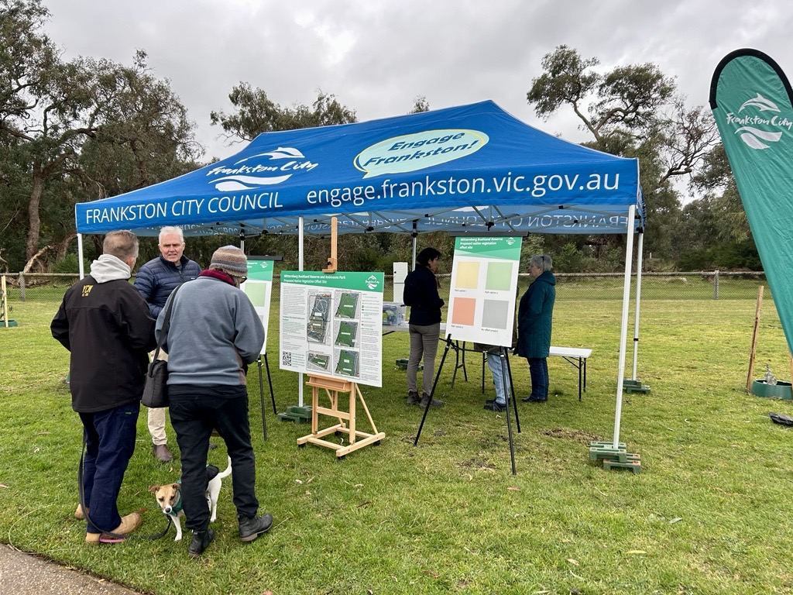
Approximately 60% of participants at the pop ups had already completed the online survey, so a second survey was not completed with these participants, and discussions held instead with Council staff and Councillor Brad Hill. Participants who had not already completed a survey were encouraged to fill it out with Council staff on the spot using iPads, or if they had limited time, a sticker was added to the poster on their preferred option, and post it notes added to reflect their feedback.

Social media

The Facebook post was seen by 3,672 people, accounting for approximately 13 per cent of the total audience reached during the engagement and well above the industry average benchmark for community engagement social media posts of 5 per cent.

Commentary on social media was largely negative, with the post shared to the Lakewood Locals Facebook group where considerable interest was generated. Examples are provided in Appendix A Communications Summary Report.

Positive insights
While the community preference for no change (and hence no offset program) for the reserve was clear. There was also very strong support for the nature conservation values of the reserve and strong support for improvements to its biodiversity.

The consultation highlighted how much the local community values this bushland reserve not only as a peaceful area for passive recreation but also for its flora and fauna diversity and the opportunity it provides to be in nature.

The need to continue to manage and enhance that diversity was highlighted in many responses.

The community also responded positively to the opportunity to inform Council’s decision on this, and strongly felt that their sentiment should be what influences Council’s decision.

Opportunities for improvement
Feedback was received from the community that the posters and postcards distributed to promote the engagement did not clearly identify the four options. While survey results indicate that the fourth (‘no change’) option was preferred by 80.4% of respondents, there was a sense from the community that the promotional material emphasised the offset options over option 4. This is valuable feedback from the community that Council will take on board when designing promotional materials.

Feedback was also received from the community that they were not as informed as they would have like to have been about the project. Council is satisfied with the number of visits to the page, and the reach that was achieved with the use of QR codes, social media, emails and newsletters, and believe that the results do reflect the community diversity and sentiment. However, we will continue to make improvements in our communications and promotion of engagements to ensure we achieve the largest reach possible.

Stakeholder feedback
In addition to the local community, key stakeholders likely to have an interest in the proposal were identified as:
- Frankston Baseball Club which utilises Robinsons Park extensively for games and training
- Frankston Environmental Friends Network (FEFN) the local peak body for biodiversity conservation organisations in Frankston with an interest in the conservation of native vegetation and biodiversity throughout the municipality
- The Bunurong Land Council Aboriginal Corporation (BLCAC), the Traditional Custodians of the area in which the reserve occurs.
Council officers gave presentations on the proposal and invited feedback at meetings of FEFN, the Frankston Baseball Club and at an internal Council officer meeting attended by representatives of the BLCAC. Officers answered questions at the sessions and encouraged individual members or Friends’ groups to participate in the on-line survey or provide submissions to Council.
The Baseball Club did not express any particular concern with the proposed change to access but noted that the club loses multiple baseballs into the bushland area adjacent to Robinsons Road and suggested that netting would solve this problem. If the baseball diamond was netted the club did not have any objections to the proposal.
There were no responses that could be identified as from FEFN members or Traditional Owners.

Council feedback
Consultation on the proposal was undertaken with Council’s Environmental Policy and Planning, Urban Design (City Futures), Open Space (Capital Works Delivery) and Parks and Vegetation (Operations) Units.
It was noted in these discussions that the available offset amount at Witternberg Reserve (1.048 General Habitat Units) is small when compared with the offset schemes of other municipalities.
An analysis undertaken by Council officers in 2020 found that only two of Council’s natural reserves, Witternberg Reserve and Studio Park, were suitable as native vegetation offsets, based on their size, vegetation quality, position in the landscape, tenure and surrounding land use. As noted in Council Report 2023/CM 2 ( February 20th 2023) Studio Park is subject to a Restrictive Covenant and the intention to use Studio Park for an offset site is fundamentally inconsistent with the existing restrictive covenant. Therefore Witternberg Reserve is the only feasible offset site available within the municipality.
Once the offset amount within Witternberg reserve is expended, it is unlikely that there will be any other Council-owned land available within Frankston that meets the criteria to be eligible as a native vegetation offset. However, the Reserve would be required to continue to be fenced and managed according to DEECA standards in perpetuity.
Capital Works provided advice on the likely timelines for delivery of Shared Use Paths that would link Witternberg Reserve and Robinsons Park with the Peninsula Link Trail under the Witternberg Masterplan.
Council’s Parks and Vegetation Unit, which manages Witternberg Bushland Reserve, has particularly emphasised the need for Council to weigh the potential community impact against the overall benefit of generating this amount of offset credits. For example, Council will need to consider the offset site establishment costs (site assessment, reporting, surveyor site plans and DEECA fees and fencing) and ongoing management (including fence maintenance) and annual monitoring costs, given the finite value of the offsets generated at Witternberg Reserve (estimated to be $141,480).
Council’s Parks and Vegetation Unit also commented on the on-going management implications of establishing the reserve as an offset site including:
- The need to consider the significant capital cost and ongoing maintenance cost of separating public access from nature by a fence, which also may affect the community’s peaceful immersive experience.
- Fire management decisions would be made by DEECA rather than Council, which could affect Council’s capacity for ecological burning.
- Management KPI’s for rapid woody weed removal under the required Offset Management Plan has potential to contribute to an influx in ground flora weeds and resulting loss of indigenous ground flora.
- ‘Wildlife friendly fencing’ carries a risk it may be vandalised. DEECA will have the authority to require Council to install a more restrictive fence if the proposed fencing does not adequately restrict dogs and people.

The Engagement Plan for this consultation included several measures of success related to the engagement objectives.

The success measures met and the objectives they relate to are outlined below:

Objective | Success Measure
Seek feedback on the establishment of the site as an Offset, including feedback on community preference for Council to instead not change access to the reserve and instead pay for offset sites in other Council areas. | Achieved: Community feedback on the proposal was clear and able to directly inform Council’s decision.
Understand the community’s support for the proposal, given a level of access restriction to the reserve is required in order for it to proceed | Achieved: Community feedback on the proposal was clear and able to directly inform Council’s decision. Community comments also communicated their understanding of the effect of the proposal. There was also higher than average engagement on the page, with people viewing the page for long enough to read the information.
Understand the community’s preference for the location of the pathway fencing (within budget and must enclose offset areas) | Achieved: Option 3 (the largest area of path) was the second most preferred option, but it was clear that over 80% of participants preferred no change to current pathways.
Engage through cost-efficient and timely methods | Achieved: High participation rates, and diverse voices, were reached through efficient means of engagement, via online Engage Frankston tools, and 2 community pop ups.
Meet legislative and policy requirements for community engagement. | Achieved: Engagement Principles met throughout the engagement, and the engagement influenced Council’s decision.

This engagement achieved a strong participation rate of 302 contributions, with a diversity of voices heard in the methods of engagement used.
Engagement outcomes clearly showed that restricting access to the reserve has been perceived negatively by the community.

Recommendations and next steps

Given the strong and clear community feedback received, recommendations for a decision have been provided in a timely manner to Council, to directly inform a decision not to proceed with the proposal.

Council officer’s recommendations for the Council meeting on 11 September 2023 are as for Council to:
- Note that Community Engagement was undertaken in relation to the proposed native vegetation offsite and Witternberg Bushland Reserve between 1 August and 27 August 2023 and during this engagement:
  - 913 people visited the engage Frankston site
  - 302 people completed the survey, and of these 243 (80.4%) prefer the no change option (compared to 18 for option 1, 7 for option 2, 33 for option 3).
- Resolve that Officers cease the investigation into a native offset site at Wittenberg reserve due to the strong community sentiment for the no change option as detailed in point 3.
- Notes that an Engagement Report on the proposed Native Vegetation Offset Site would be provided on the Engage Frankston website; and.
- Notes that no further report will be presented to Council on consultation outcomes of native offset site at Wittenberg reserve
Following Council’s decision, this Engagement Report will be published on Engage Frankston, and interested community members will be notified.

Appendix A | Witternberg Communications Wrap Up
Appendix B | Witternberg Offset Survey Results Summary

Appendix A
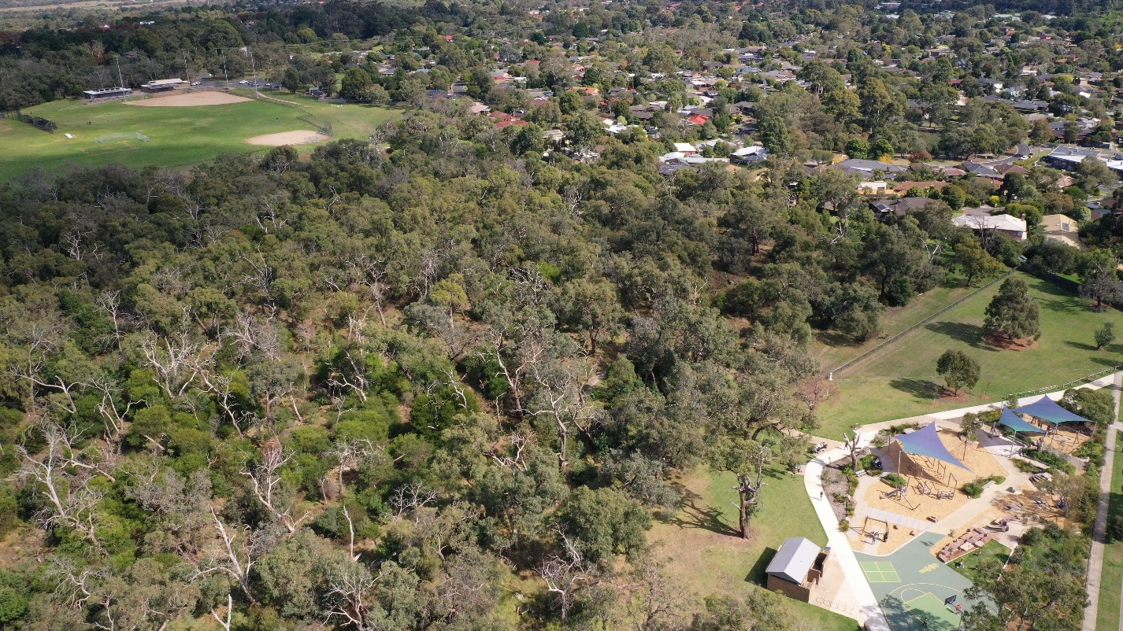

Witternberg Reserve communications support
Engagement period: 1 August to 27 August

Facebook
Introductory post: 3 August
“Frankston City Council is exploring options to establish sections of Witternberg Bushland Reserve as a Native Vegetation Offset Site...”
Analysis
We posted once on Facebook for the Witternberg Reserve project. It was important to let the community know about the project, however, we didn’t want more than one two-way communication method given the negative feedback. The post was seen by 3,672 people, accounting for roughly 13 per cent of our audience. This is above the industry average benchmark of 5 per cent. Commentary was largely negative, with our post shared to the Lakewood Locals Facebook group (see screen shots below).
Link: https://www.facebook.com/FrankstonCityCouncil/posts/pfbid02yx4C6sB2mAgRLdBqYkkYSgzHR9SJY4BT5jdSLznZjBNDjKLZtbfseNUEusfYGSUfl
Post visual:
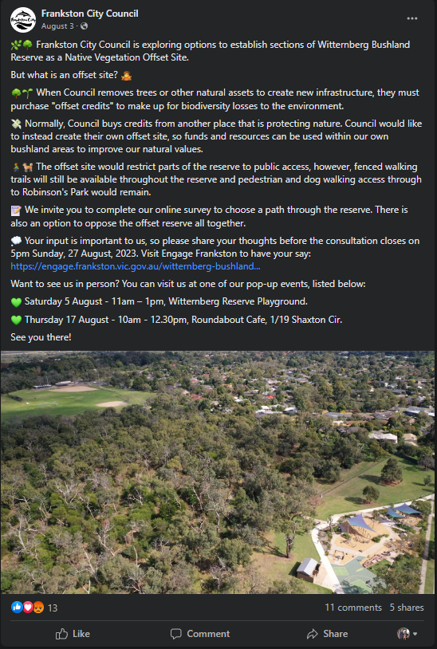
Comments:
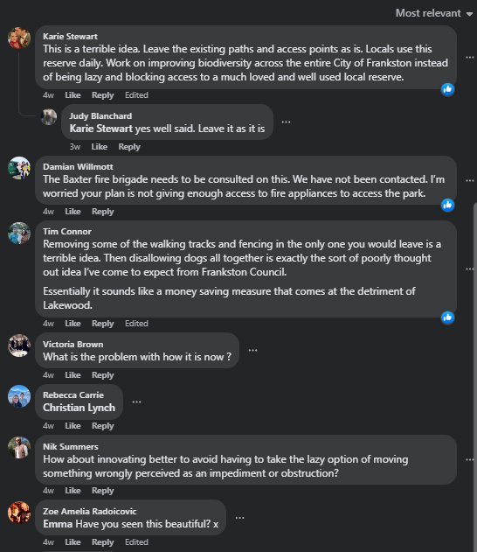
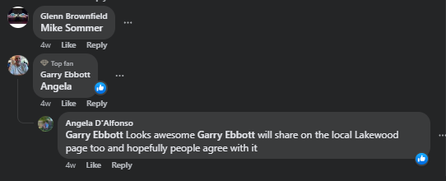

Analytics report:
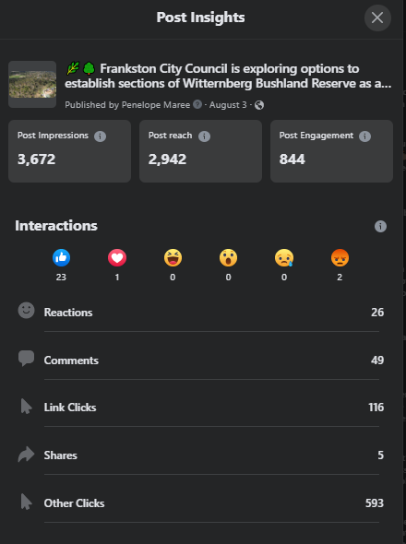
Commentary on Lakewood Locals closed Facebook group
Analysis: There are 14 posts relating to the proposed offset site at Witternberg Reserve. Half of these are from one resident. Community sentiment is strongly against the offset project, with some complaints about Council’s process. There are approximately 150 comments across these 14 posts.

E-News
The August edition of the newsletter was sent to 3,420 recipients. 1,935 of those recipients opened the newsletter, with 89 total link clicks for Witternberg Reserve.

Printed material

One QR code was used across all print collateral, including posters, postcards and letters. This resulted in 119 scans.

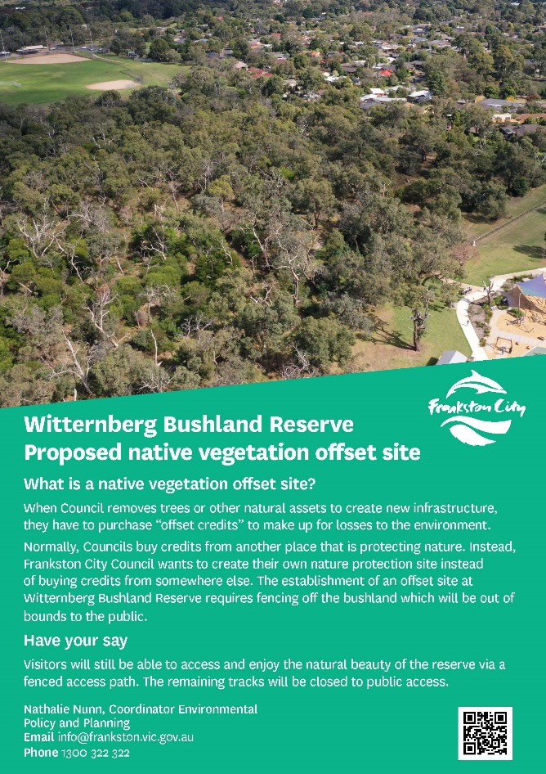
Posters

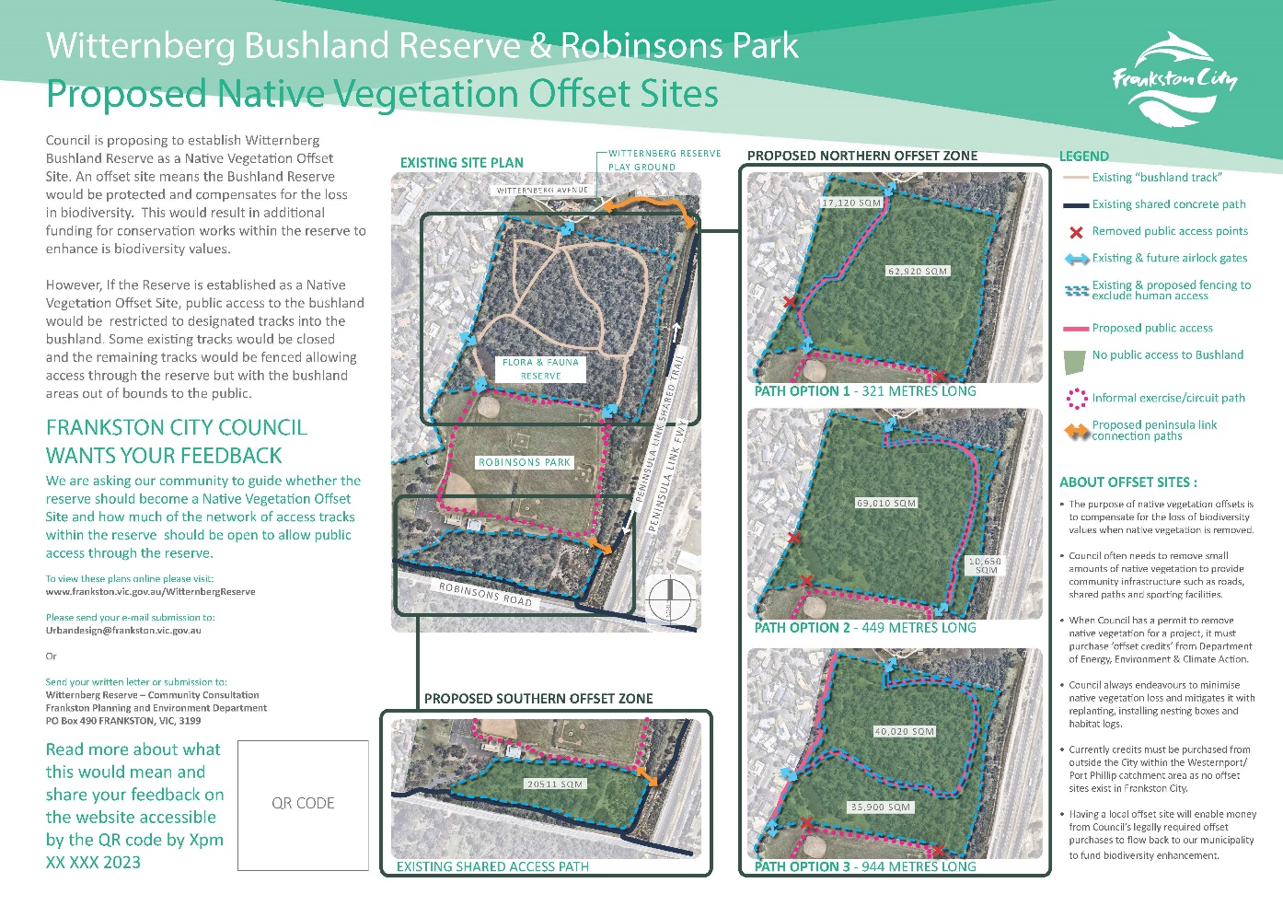

Postcard
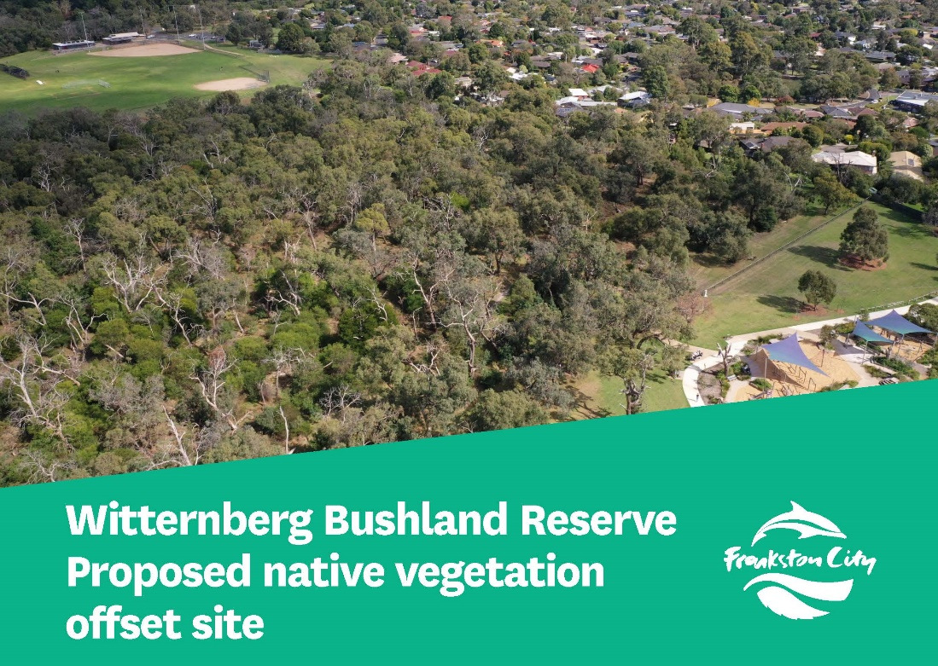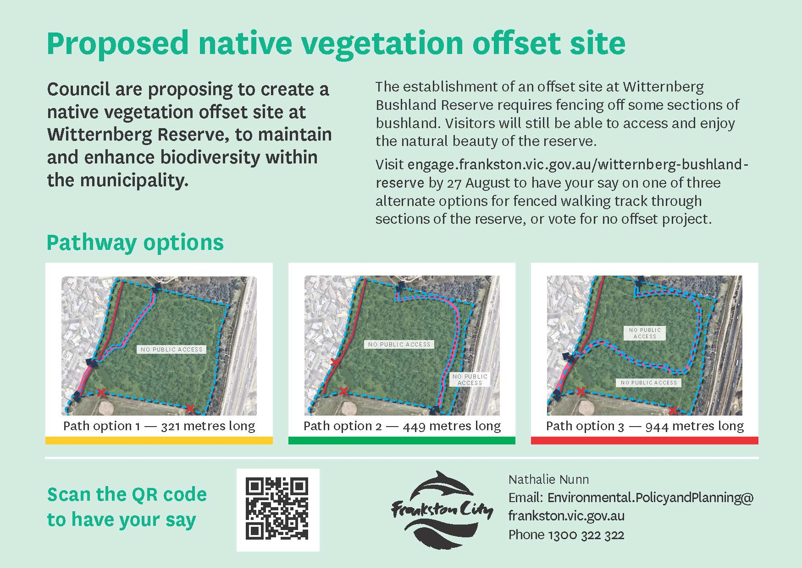

Letters/Email
58 letters were sent to adjoining residents on 3 August 2023.
An email was sent to 58 recipients who took part in the Witternberg Reserve Masterplan community consultation process.
4 schools were emailed a letter on 15 August 2023. These include St Augustine’s Primary, Kingsley Park Primary, Bayside Christian College, and Mt Erin College.
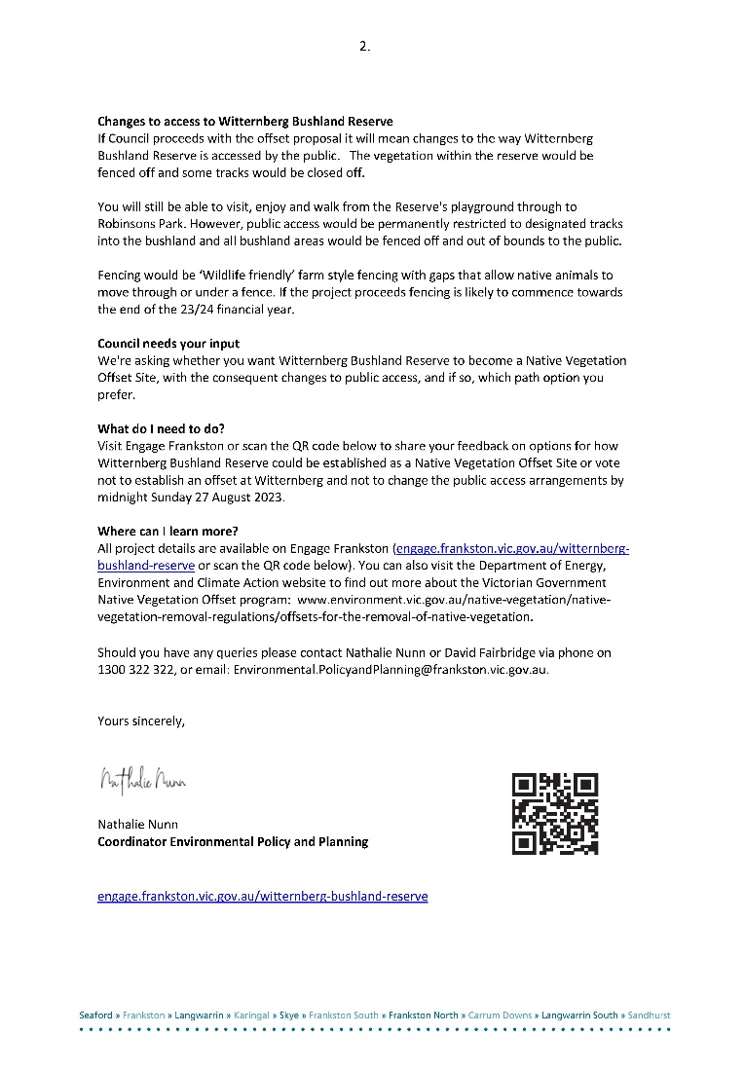
Below is an example of a letter (contents remained largely the same but altered slightly depending on audience).
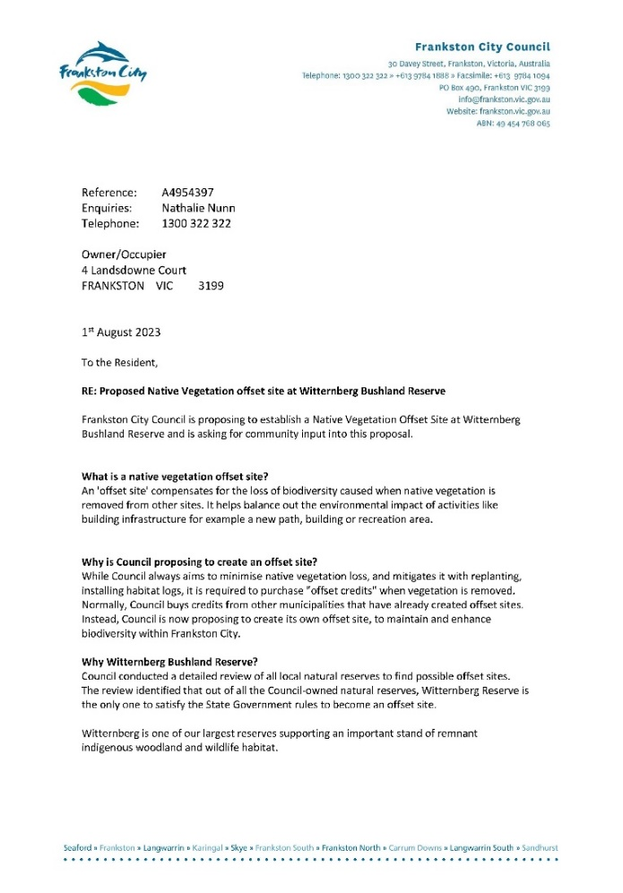

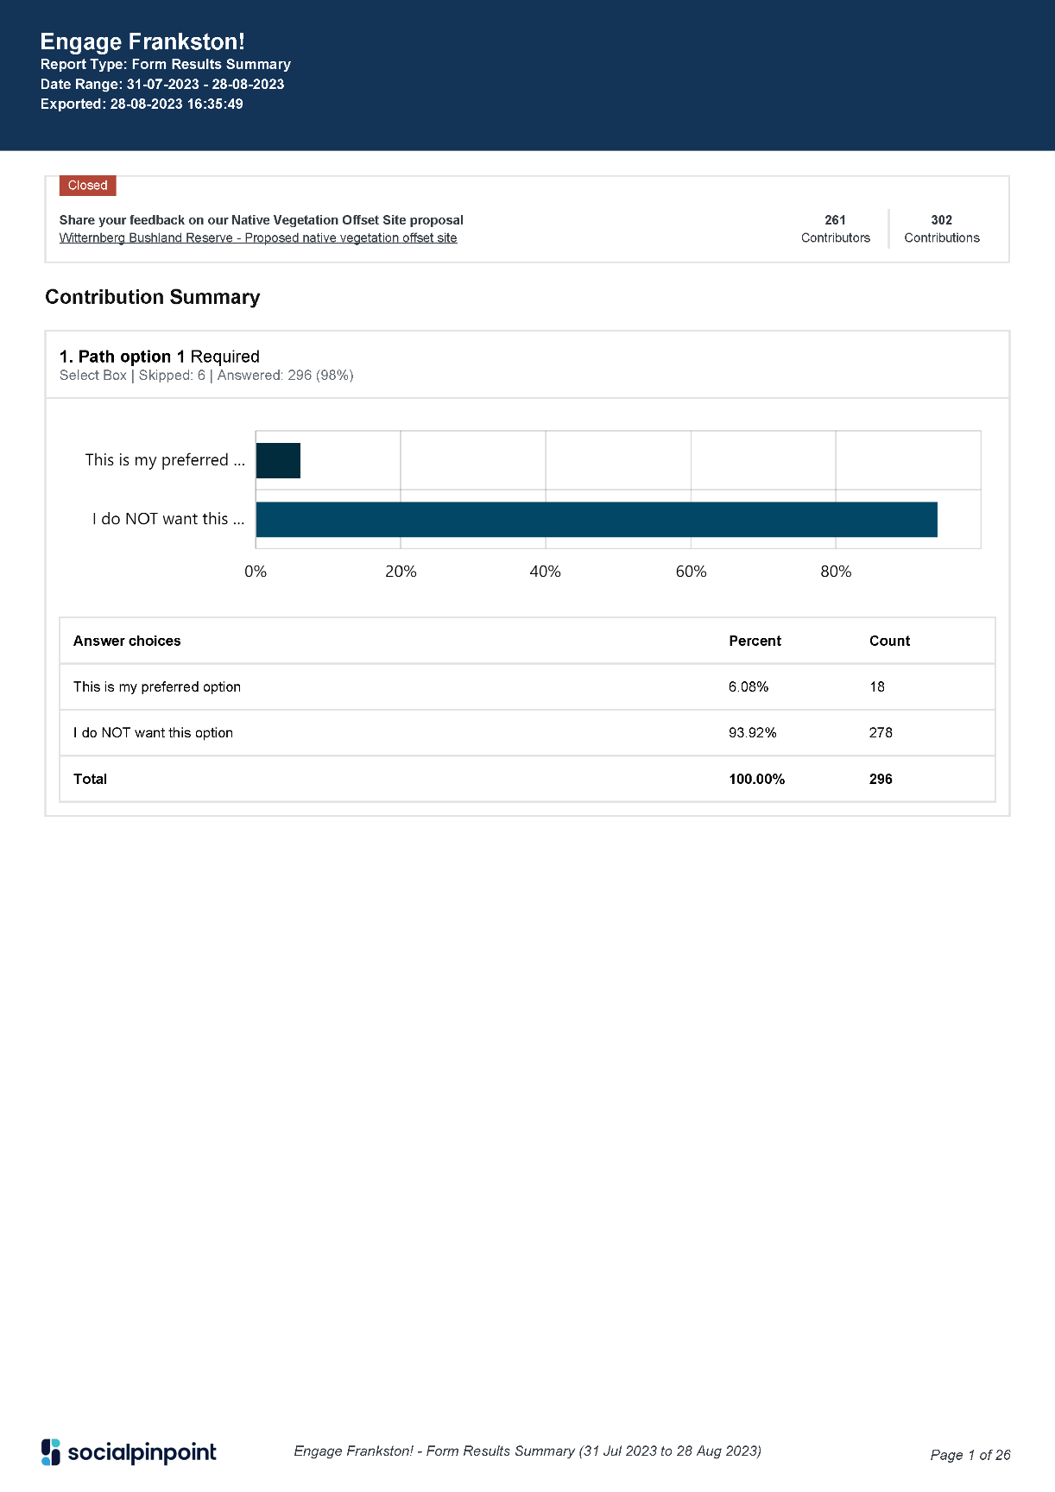
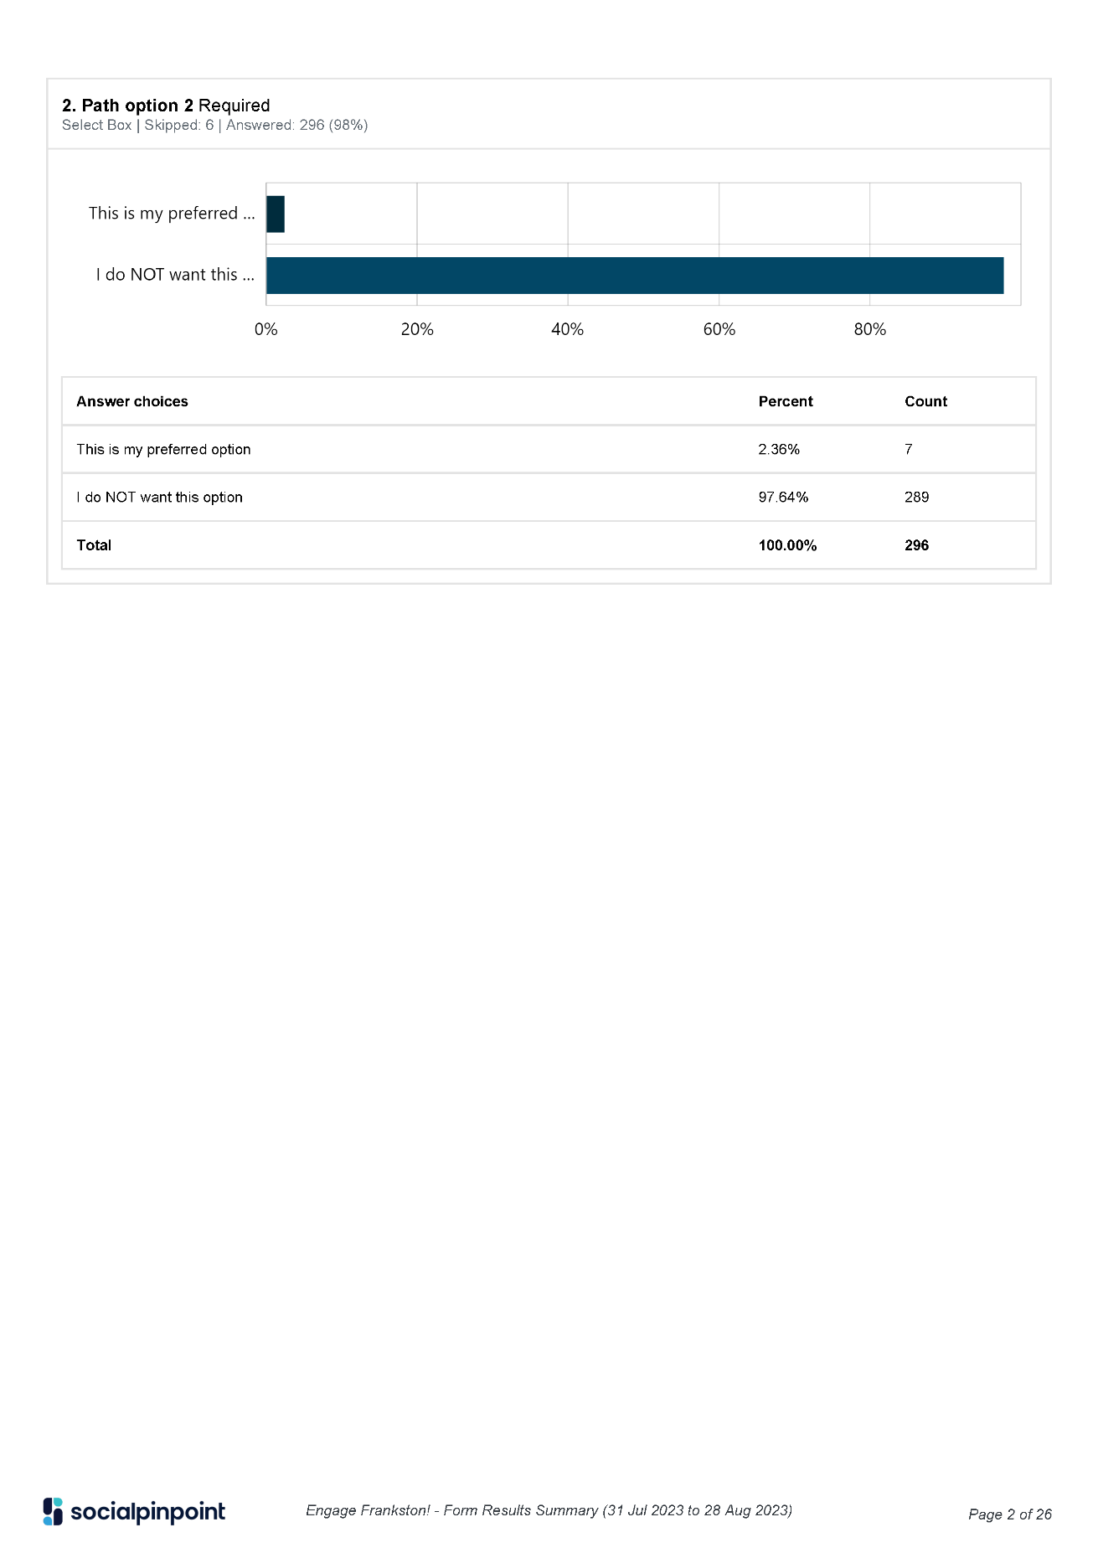
Appendix B