Your vision for Frankston City
Completed surveys can be scanned or clearly photographed and emailed to engagement@frankston.vic.gov.au or returned by post so that they are received by 31 May 2021. Mail to:
Attention: Community Engagement
Civic Centre
30 Davey Street
Frankston VIC 3199

What do you want Frankston City to be like in 2040?
Our Community Vision 2040 was created by our community in 2021 to describe what it hopes the future will be like in Frankston City.
We want to know, is your vision for the future of our City the same as what was agreed by our community in 2021? Has anything changed for you or our community?
Your feedback will help us to review our Community Vision 2040 and to develop our new Council Plan 2025-2029, which is how Council helps to deliver our community’s Vision. It will also help us to refresh our Asset Plan 2022-2032 and Financial Plan 2021-2031

Our Community Vision 2040:

"Frankston City 2040 is the place on the bay to learn, live, work and play in a vibrant, safe and culturally inclusive community. Our City is clean, green and environmentally responsible"​
Does the Community Vision 2040 describe the future Frankston City that you would like to see?
Select one answer only
Yes
No
Unsure
What words connect most with your vision for Frankston City 2040?
In a few words describe your vision for Frankston City 2040.

How do Council's services support our Community Vision 2040?
Since 2021, Council has been working to achieve our Community Vision 2040 by delivering services under our Council Plan 2021-2025.
During this time, we've heard from our community that you'd like Council to focus more on some services, less on others, or improve delivery of some services.
We'd like to learn more about this so that we can develop a new Council Plan 2025-2029.

- Rank the six service groups to tell us which ones are most important to you and your community. ^{Required}
Number the boxes 1 to 6, from more important to least important
Safety, ageing, children, library, kinder, sport
Support people in need, grants, emergency relief
Parks, playgrounds, waste, protect environment
Parking, roads, footpaths, bike paths
Festivals, events, businesses, planning permits
Rates, finances, customers, buildings, technology

Share your feedback on our services - what do you want Council to focus more, less or the same on?
We're seeking your feedback on the individual services delivered under each of the six service groups (‘themes’). You have the option to respond to one theme, or up to six themes. Select the box to expand each set of questions for each theme.

Healthy and safe communities
Safety, ageing, children, kinder, sport

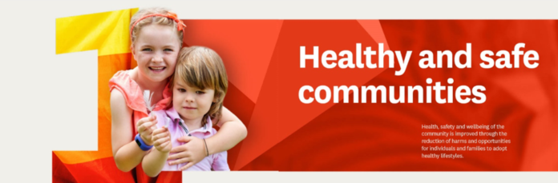

Community health
We support education, healthcare and community wellbeing, and provide fair access to services and support.

Tell us what you would like Council to focus more, less or the same on.

 | More | The same | Less | Not sure
Children’s services: health and immunisation, playgroups, kindergarten enrolments

Services for our ageing population: home maintenance, transport, outings and meals

Services for our ageing population: home maintenance, transport, outings and meals

Health and wellbeing programs (all ages): support to access healthy food, support to reduce harm from gambling, tobacco, e-cigarettes, alcohol and drug use

Please share your reasons. We'd like to hear if you and your community would like more of any existing services, or any new Community Health services?

Sport and recreation
We encourage people to be healthy and active by planning recreation opportunities through programs and sporting clubs. We coordinate and support sporting clubs and manage their use and care of facilities. We also help plan the right facilities in the right locations.

Tell us what you would like Council to focus more, less or the same on.

 | More | The same | Less | Not sure
Managing sporting groups and their needs (e.g. facilities, grounds)

Supporting sports clubs to be inclusive and welcoming for all

Programs to increase participation in sport and active recreation

Please share your reasons

Community safety
We promote and protect the health and amenity of our community and enhancing liveability, by providing community safety initiatives, education and ensuring compliance with legislation.

Tell us what you would like Council to focus more, less or the same on.

 | More | The same | Less | Not sure
Animal management and pet registration

City safety: initiatives to ensure community safety (e.g. monitored security cameras, crime prevention, school crossings)

Support community during emergencies and natural disasters

Please share your reasons

Community development
We empower vulnerable community members to be more independent and resilient. We provide accessible activities, services, campaigns and community spaces.

Tell us what you would like Council to focus more, less or the same on.

 | More | The same | Less | Not sure
Financial grants for community groups and organisations

Youth services for 12-24 year-olds

Emergency relief and support for vulnerable people

Community centres

Initiatives that prevent violence against women and promote gender equality

Programs that support volunteering

Initiatives that strengthen respect and value of diversity, social inclusion and mental wellbeing

Initiatives that improve safety and wellbeing related to homelessness

Strengthening reconciliation and respect for Aboriginal and Torres Strait Islander culture and history

Please share your reasons

Community Strength
Support people in need, libraries, arts, community grants, emergency relief

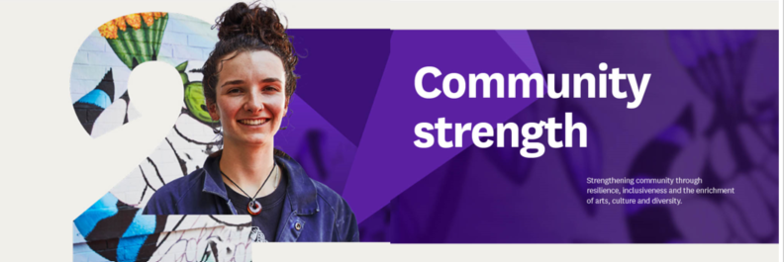
Strengthening community through resilience, inclusiveness and the enrichment of arts, culture and diversity.

Community health
We support education, healthcare and community wellbeing, and provide fair access to services and support.
Tell us what you would like Council to focus more, less or the same on.

 | More | The same | Less | Not sure
Children’s services: health and immunisation, playgroups, kindergarten enrolments

Services for our ageing population: home maintenance, transport, outings and meals

In home support (all ages): domestic assistance, personal care and respite

Health and wellbeing programs (all ages): healthy eating and food security programs, support to reduce harm from gambling, tobacco, e-cigarettes, alcohol and drug use

Please share your reasons. We'd like to hear if you and your community would like more of any existing services, or any new Community Health services?

Community development
We empower vulnerable community members to be more independent and resilient. We provide accessible activities, services, campaigns and community spaces.

Tell us what you would like Council to focus more, less or the same on.

 | More | The same | Less | Not sure
Financial grants for community groups and organisations

Youth services for 12-24 year-olds

Emergency relief and support for vulnerable people

Community centres

Initiatives that prevent violence against women and promote gender equality

Programs that support volunteering

Initiatives that strengthen respect and value of diversity, social inclusion and mental wellbeing

Initiatives that improve safety and wellbeing related to homelessness

Strengthening reconciliation and respect for Aboriginal and Torres Strait Islander culture and history

Please share your reasons

Arts and Culture
We support the delivery of arts programs, events, festivals, sector development, public art and welcoming cultural facilities. We manage Frankston Arts Centre, and contribute to positioning Frankston City as a creative and vibrant destination.
Tell us what you would like Council to focus more, less or the same on.

 | More | The same | Less | Not sure
Outdoor festivals and events

Theatre shows and workshops

Exhibition and public art (street art and sculptures)

Library collection and programs
Please share your reasons. Are there any new arts opportunities or events you'd like to see in Frankston City?

Sustainable environment
Parks, playgrounds, waste, protect environment

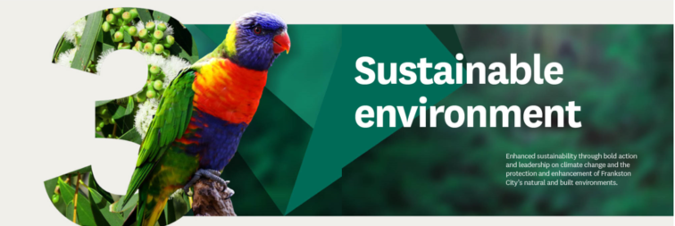
Enhanced sustainability through bold action and leadership on climate change and the protection and enhancement of Frankston City’s natural and built environments.

Biodiversity and open space
We provide high quality, sustainable natural and open spaces.
Tell us what you would like Council to focus more, less or the same on.

 | More | The same | Less | Not sure
Playgrounds and open space planning and maintenance

Protection of native animals and biodiversity

Planting and protecting trees to create cooler, greener streets and open spaces

Please share your reasons

Climate change action
We support the community and Council to improve energy efficiency, adopt renewable energy and reduce carbon emissions.

Tell us what you would like Council to focus more, less or the same on.

 | More | The same | Less | Not sure
Delivering energy saving and emissions reduction in Council owned buildings

Assist community to reduce the impacts of climate change

Please share your reasons

Integrated water
We manage stormwater, drainage, and water approvals. We also protect, enhance and conserve our water resources.
Tell us what you would like Council to focus more, less or the same on.

 | More | The same | Less | Not sure
Stormwater management and flood planning

Drainage maintenance

Protect, conserve and enhance our water resources

Please share your reasons

Waste and recycling
We collect waste, recover resources, manage landfill and the Frankston Regional Recovery and Recycling Centre, and operate waste prevention programs.
Tell us what you would like Council to focus more, less or the same on.

 | More | The same | Less | Not sure
Provide convenient options to dispose of waste and recycling

Community education and tools to minimise waste

Please share your reasons

Well planned and liveable city
Parking, roads, footpaths, bike paths

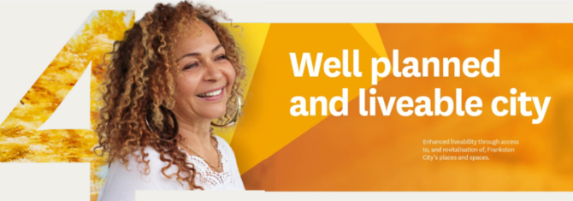
Enhanced liveability through access to, and revitalisation of, Frankston City’s places and spaces.

Transport connectivity
We support safe movement into, around and out of Frankston City.
Tell us what you would like Council to focus more, less or the same on.

 | More | The same | Less | Not sure
Plan connections between walking, riding and driving

Provide a safe, connected and accessible transport network

Take care of Council managed roads

Easy access to e-bikes and e-scooters

Please share your reasons

Parking
Council provides on and off-street parking and ensures car parking options are available for the community.
Tell us what you would like Council to focus more, less or the same on.

 | More | The same | Less | Not sure
Provide parking options to meet the needs of motorists and the community

Effective and responsible parking enforcement

Please share your reasons

City planning
Building, maintaining and improving a liveable city in line with the Frankston City Planning Scheme. We process applications for planning, building and renovations, and enforce planning rules.
Tell us what you would like Council to focus more, less or the same on.

 | More | The same | Less | Not sure
Long term planning to guide the locations of homes, public space, commercial and industrial areas.

Plan and advocate for affordable housing to help prevent homelessness.

Please share your reasons

Thriving economy
Festivals, events, businesses, planning permits

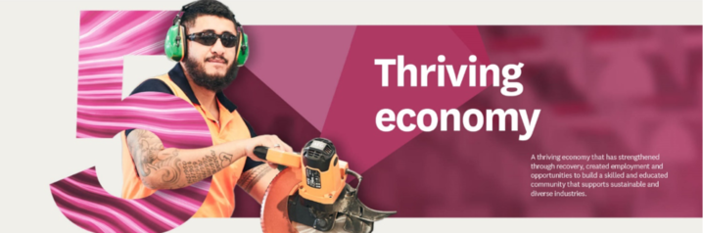
A thriving economy that has strengthened through recovery, created employment and opportunities to build a skilled and educated community that supports sustainable and diverse industries.

Supporting business and industry
We work collaboratively with business and the community to ensure that Frankston City has a sustainable and prosperous local economy.
Tell us what you would like Council to focus more, less or the same on.

 | More | The same | Less | Not sure
Provide business development and training to our business community

Strengthen the City’s brand and economy

Future investment programs (e.g. business grants)

Creating vibrant public spaces

Initiatives that promote inclusion and lifelong engagement in education, training and employment

Please share your reasons

Arts and Culture
We support the delivery of arts programs, events, festivals, sector development, public art and welcoming cultural facilities. We manage Frankston Arts Centre, and contribute to positioning Frankston City as a creative and vibrant destination.
Tell us what you would like Council to focus more, less or the same on.

 | More | The same | Less | Not sure
Outdoor festivals and events

Theatre shows and workshops

Exhibition and public art (street art and sculptures)

Library collection and programs
Please share your reasons. Are there any new arts opportunities or events you'd like to see in Frankston City?

City planning
Building, maintaining and improving a liveable city in line with the Frankston City Planning Scheme. We process applications for planning, building and renovations, and enforce planning rules.
Tell us what you would like Council to focus more, less or the same on.

 | More | The same | Less | Not sure
Long term planning to guide the locations of homes, public space, commercial and industrial areas.

Plan and advocate for affordable housing to help prevent homelessness.

Please share your reasons

Progressive and engaged city
Rates, finances, customers, buildings, technology

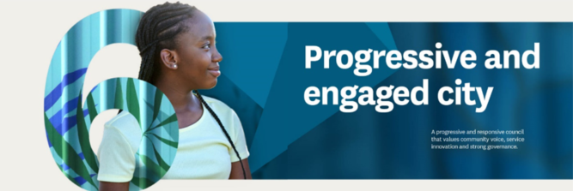
A progressive and responsive council that values community voice, service innovation and strong governance.

Customer experience
We provide a link between customers and council services by actively listening to customer needs, responding to feedback, communicating about council services, and improving services.
Tell us what you would like Council to focus more, less or the same on.

 | More | The same | Less | Not sure
Face to face customer service

Online digital customer service

Customer service over the phone

Improving community facing services (e.g. one-stop-shop and tracking of customer requests)

Clear and consistent communications to the community (e.g. social media, Frankston City News)

Information services for visitors

Customer complaints and feedback handling

Please share your reasons

Technology and innovation
We manage technology, business applications, data and information for Council.
Tell us what you would like Council to focus more, less or the same on.

 | More | The same | Less | Not sure
City connectivity: including Wi-Fi in public places, interactive signage.

Smart cities: including smart parking, real time road maintenance alerts

Ongoing investment to strengthen data security and privacy

Please share your reasons

Council strategy
We provide leadership and support to ensure Council meets current and future community needs. We deliver program and project management and analyse and report on performance.
Tell us what you would like Council to focus more, less or the same on.

 | More | The same | Less | Not sure
Community engagement to support participation in council decision-making

Advocating with all levels of government and other stakeholders

What would you like Council to advocate for (e.g. roads, buildings, pavilions, community services, aged care, kindergartens, support for vulnerable people)? Please share your reasons.

Asset management
Making sure Council assets support current and future service delivery, including fleet management.
Tell us what you would like Council to focus more, less or the same on.

 | More | The same | Less | Not sure
Regular and structured assessments of Council owned assets

Security, cleaning and maintenance of Council managed buildings

Please share your reasons

Council internal services
Council provides:
- Leadership and support in financial planning, processing and reporting to ensure Council’s long term financial position is sustainable.
- Governance, legislative, procurement and financial advice to the organisation, and management of Frankston Memorial Park.
- Management of people, culture and workforce performance.
Is there anything you would like us to tell about our Financial Management, Governance and/or People and Culture services?

A bit about you
Your responses help us understand who is interested in and impacted by this project.

Where do you live?
Select one answer only
Carrum Downs
Frankston
Frankston North
Frankston South
Langwarrin
Langwarrin South
Sandhurst
Seaford
Skye
Prefer not to answer
Somewhere else

How do you describe your gender? ^{Required}
Select one answer only
Woman or female
Man or male
Non-binary
Prefer not to answer
I use a different term

What is your age?
Select one answer only
0 - 4 years
5 to 11 years
12 to 17 years
18 to 24 years
25 to 34 years
35 to 49 years
50 to 59 years
60 to 69 years
70 to 84 years
85 years and over
Prefer not to answer
Which of the following do you identify with?
Choose all that apply.
Select all that apply
Person with a disability.
Aboriginal and/or Torres Strait Islander.
Part of the LGBTIQA+ community.
Speak another language at home.
None of these.
Prefer not to answer.

