Have your say on the Draft Leisure Strategy 2021-2029
Health, wellbeing and leisure in Frankston City – Survey
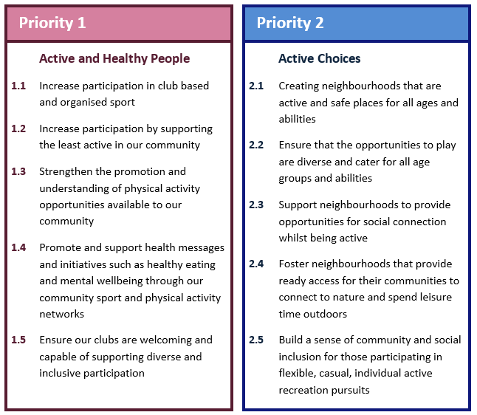
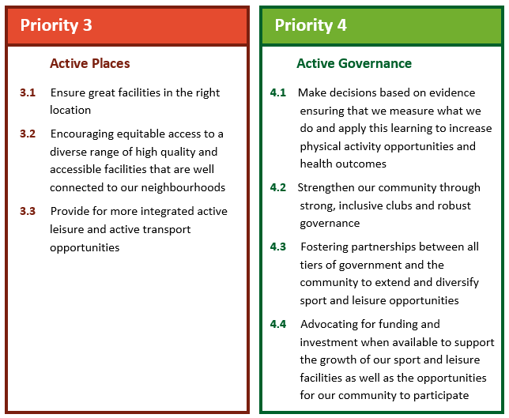
Please read through these Leisure Strategy Priorities and let us know if there is anything missing.

Are you satisfied that the priorities identified in our Draft Leisure Strategy focus areas meet our community’s needs?

Yes No Unsure

If no or unsure, can you tell us why? Is there anything that’s missing or needs to be changed?

Have your say on the Draft Health and Wellbeing Plan 2021-2025
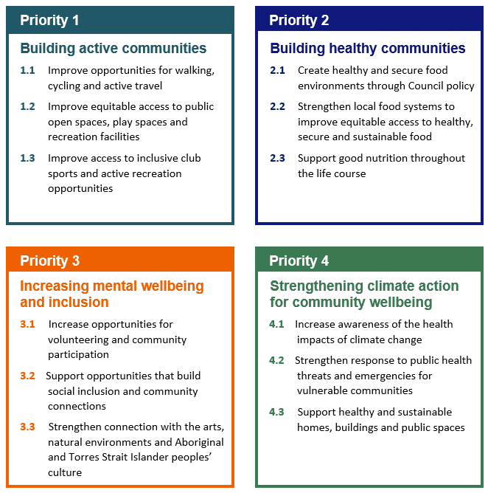
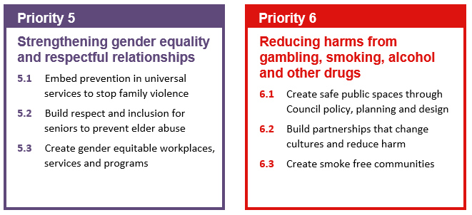
Please read through these Health and Wellbeing Plan Priorities and let us know if there is anything missing.

Are you satisfied that the priorities identified in our Draft Health and Wellbeing Plan priorities meet our community’s needs?

Yes No Unsure

If no or unsure, can you tell us why? Is there anything that’s missing or needs to be changed?

We want your ideas for turning our priorities into action!
What are your ideas for what we can do to get people more physically active in your local area and in our open spaces, parks and reserves?

What are your ideas for what we can be doing in your local area to take action on the objectives for our other health and wellbeing priorities?

Privacy Statement
The information on this page is being collected and used by Council in the exercise of its powers and functions under legislation (including the Local Government Act from 2020) in order to achieve its purposes as provided in the legislation. Your personal information will only be disclosed outside Council with your consent, or where required or permitted by law. For instance, Council may disclose your personal information to its contractors, credit providers or professional advisors to assist Council to perform its functions. This information will not otherwise be disclosed without your consent or as required or permitted by law. The information will only be amended upon receipt of written instructions either from yourself or from parties authorised to act on your behalf. You have a right to access your personal information subject to some exceptions allowed by law. If you have any questions related to privacy, please contact Council's Privacy Officer on 1300 322 322.

