Reference: A4444502
Gould Street Upgrade Works Concept Design Project

<First Owner Name> <&> <Second Owner Name>
<Address>
<Suburb.State>

Thursday 06 May, 2021

<Name>,

COMMUNITY PARTICIPATION – PLANNING FOR GOULD STREET UPGRADE INCLUDING DRAINAGE WORKS AND PEDESTRIAN ACCESS TO FORESHORE

You may be aware that the road and street infrastructure within the Gould Street precinct is ageing and therefore will require upgrades in the future. Concerns raised with Council relate to the street’s current condition, and what the future streetscape will look like, taking into consideration drainage, paths, kerbside and traffic.
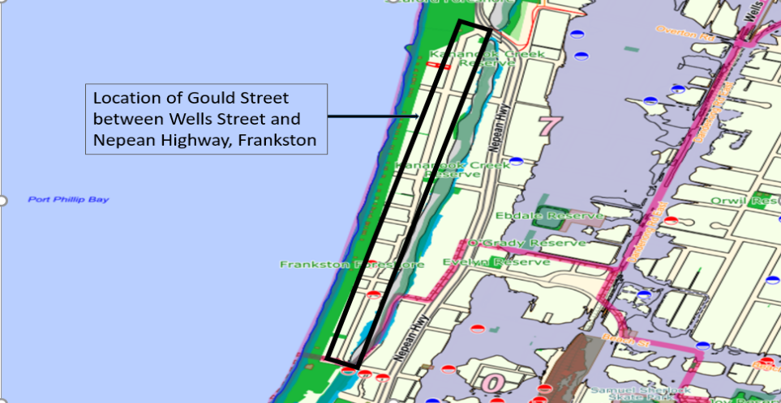

As asset manager, Council has a responsibility to ensure the precinct meets the needs of residents and broader community in the short-term, while remaining sustainable in the long-term.
To further inform future upgrade works, and to complement the investigation already underway by Council, we are seeking resident input to help identify current traffic, safety, foreshore access and drainage issues.
Your feedback will help Council to develop a draft Concept Design, which will be presented back to the community at a later date for consideration prior to any works commencing.
Providing feedback
Residents can provide their input and feedback via the following pathways:
- Online by visiting: frankston.vic.gov.au/HaveYourSay
- By email: info@frankston.vic.gov.au
- In person: Attend our Community Meeting
  - Tuesday 25 May, 6.30pm, Mechanics Hall, Plowman Place, Frankston (Parking available)
Please note, feedback closes Thursday 27 May 2021
Next steps
Once a draft concept design has been established a period of community engagement will follow, offering residents another opportunity to provide feedback on the proposed works.
When the final concept is completed, the works will then be programmed by inclusion in Council’s Long Term Infrastructure Plan. It is envisioned that the initial focus will be on foreshore accessibility and improved drainage.
Note, we will ensure residents and the wider community remain informed on the project as it is rolled out including works programming.
Further information
Please contact Council’s Infrastructure Engineer, Kizito Essuman.
Phone 1300 322 322 or email info@frankston.vic.gov.aum, Attn: Kizito Essuman
Please RVSP by Friday, 21 May 2021 for attendance and Covid-19 Protocol management.

Yours faithfully,
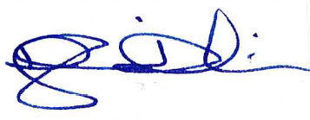

Douglass Dickins
MANAGER ENGINEERING SERVICES

