# 

**Quick Engagement Stats - 20/09/21 – 06/10/21**

Out of **61 responses** submitted to Council, the following Sentiment was received about the Draft Concept Plan:

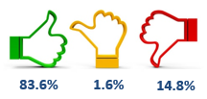

The following responses were received to these Questions:

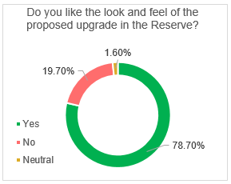 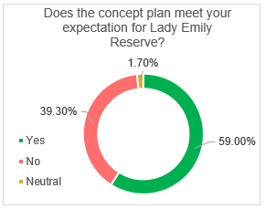

**Engagement – Lady Emily Reserve**

**Project Title**

*Lady Emily Reserve Playground Construction and Park Upgrade*

**Project Overview**

**Project overview**

Lady Emily Reserve is a local-level park serving the surrounding residential area of Skye. The nearest playground is located 300 metres away at Heyson Reserve.

As part of Council’s commitment to improving play and based on recommendations in the City of Frankston Play Strategy (2021), the refurbishment of the play space and park at Lady Emily Reserve has been highlighted as a priority.

The design of a new play space and park improvements at Lady Emily Reserve will also be guided by the City of Frankston Open Space Strategy and the Community Vision (2040).

**Engagement purpose**

To present the community with the draft concept plan outlining proposed park and play space improvements at Lady Emily Reserve and seek feedback on the concept design from the surrounding residents that will be used to shape the final concept plan.

**Community Consultation Process**

**Postcards and park signage**

* Postcards delivered to 400 surrounding homes with information about the project and a call to action to visit Engage Frankston to tell us what you think.
* Signage in the park with project information and a QR code enabling residents to visit Engage Frankston.

**Online engagement**

*Overview of online engagement*

* *Via* [**Engage Frankston website**](https://engage.frankston.vic.gov.au/lets-play/lady-emily-reserve-skye)
* *Via* Facebook Frankston City Council post

**Stakeholder engagement**

*Stakeholders that were involved & how*

* Skye Primary School

**Recommendations & Next Steps**

**Recommendations**

*Summary of the recommendations*

* Many requests have been incorporated into the final concept plan.

Requests for a larger type of play space cannot be accommodated at Lady Emily Reserve due to the size of the park and the available budget.

Based on recommendations in Council’s Play Strategy (2021), nearby Heyson Reserve will be considered for a larger style play space due to the larger size of this reserve.

**Next Steps**

It is anticipated that construction will start in February, 2022 and take approximately 12-weeks to complete.

Detailed construction information will be provided to the community before construction starts.

**Summary of outcomes**

**Community Outcomes**

*Summary of how the engagement influenced the project*

A majority of comments were positive, welcoming the upgrade. There were also requests to make the play space larger and include more activities.

The comments and feedback received could generally be grouped into four themes:

* Realigning proposed path entrances at Nimman Mews;
* Requests to include activities for older children such as basketball;
* Requests for an in-ground trampoline;
* Requests for shade and park fencing.

*How the engagement influenced the project:*

Based on feedback received from the community, the following changes have been made to the concept plan:

* A basketball tower and key has been added to the park;
* An in-ground trampoline has been added to the play space;
* Shade sails are included over much of the play space and a picnic shelter will be located on the western side of the paly space;
* An additional picnic table setting has been included.