Feedback on draft Safer Communities Policy and Strategy

Introduction

We are seeking your feedback on the Draft Policy and Strategy. We're particularly keen to hear feedback on:
- Our proposed vision for a safer Frankston City
- The initiatives proposed to deliver on the strategic priorities.
We have included in our survey a selection of proposed initiatives that Council is proposing to directly deliver to our community.
We welcome feedback on our proposed strategies and initiatives via our ‘general’ feedback question below. To see the full list, please see our Draft Strategy. Or see our summaries as they relate to our community’s top safety concerns here:
- Build strong, inclusive and connected communities
- Strengthen community wellbeing and resilience
- Build well planned and liveable environments for safety
- Improve access to safe and secure housing
- Strengthen leadership, partnerships and community empowerment.

Section 1: Our Vision Statement

We have drafted the following Vision Statement, using input from our community and stakeholders:
Frankston City is a safe, fair and inclusive community that values diversity, connection and participation.
- Do you support our draft Vision Statement? ^{Required}
Select one answer only
Yes
No
Unsure
- Let us know your reasons

Section 2: Proposed initiatives

Strategic priority 1.1: Build strong, inclusive and connected communities
Read more detail about the priorities and initiatives here.
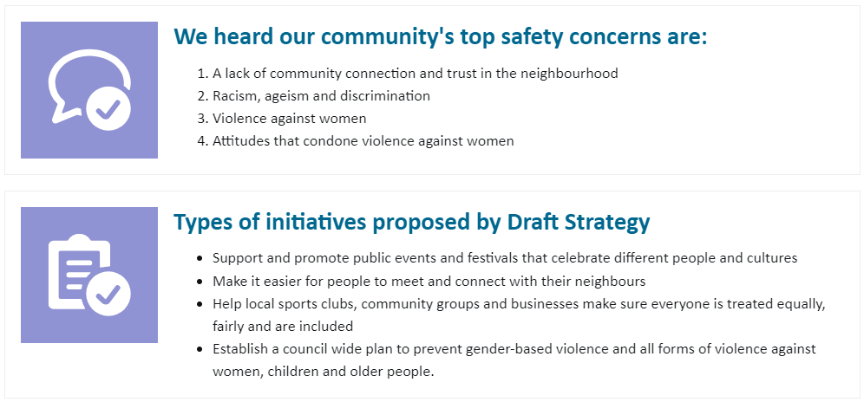
Click on above text to enlarge it
- Do you believe these initiatives will help to address your safety concerns?
___ / 5
- Let us know and comments, suggestions or concerns you have.

Strategic Priority 2.1: Strengthen community wellbeing and resilience
Read more detail about the priorities and initiatives here.
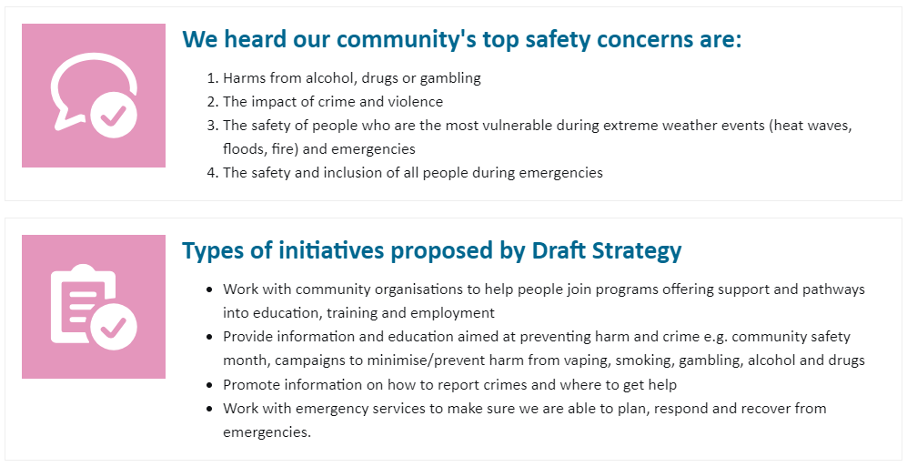
Click on above text to enlarge it
- Do you believe these initiatives will help to address your safety concerns?
___ / 5
- Let us know and comments, suggestions or concerns you have.

Strategic priority 3.1: Build well planned and liveable environments for safety
Read more detail about the priorities and initiatives here.
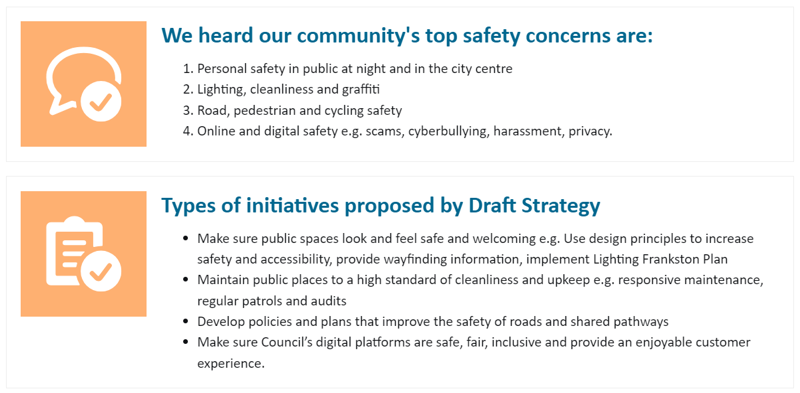
Click on above text to enlarge it
- Do you believe these initiatives will help to address your safety concerns?
___ / 5
- Let us know and comments, suggestions or concerns you have.

Strategic priority 3.2: Improve access to safe and secure housing
Read more detail about the priorities and initiatives here.
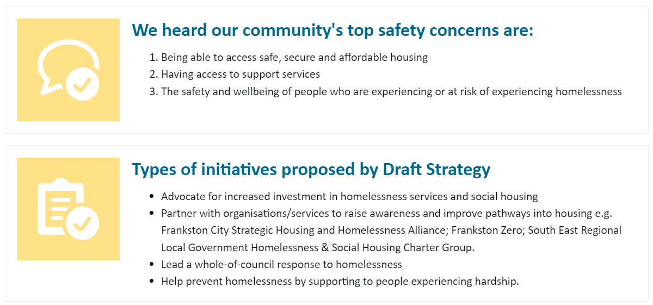
Click on above text to enlarge it
- Do you believe these initiatives will help to address your safety concerns?
___ / 5
- Let us know and comments, suggestions or concerns you have.

Strategic priority 4.1: Strengthen leadership, partnerships and community empowerment
Read more detail about the priorities and initiatives here.
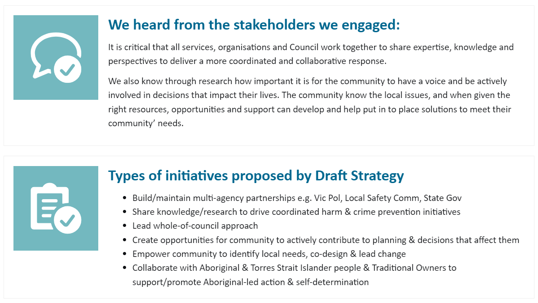
Click on above text to enlarge it
- Do you believe these initiatives will help to address your safety concerns?
___ / 5
- Let us know and comments, suggestions or concerns you have.

Section 3: General feedback

- Do you have any other comments, suggestions or concerns about the Draft Safer Communities Policy and Strategy?

Section 4: Tell us about yourself

These questions helps us to understand if we reached all the people we hoped to hear from. You can select 'prefer not to say'.
- What is your gender? ^{Required}
Select one answer only
Woman
Man
Non-binary
Prefer not to say
I use another term (please specify)

- What is your age group? ^{Required}
Select one answer only
Under 15 years
15-17
18-25
26-35
36-45
46-55
56-65
66-75
76-85
86+ years
Prefer not to say
- Where do you live? ^{Required}
Select one answer only
Carrum Downs
Frankston
Frankston North
Frankston South
Karingal
Langwarrin
Langwarrin South
Sandhurst
Seaford
Skye
Prefer not to say
Other

- Do you identify as LGBTQIA+? ^{Required}
Select one answer only
Yes
No
Prefer not to say
- Do you identify as Aboriginal and/or Torres Strait Islander? ^{Required}
Select one answer only
Yes
No
Prefer not to say
- Do you speak a language other than English? ^{Required}
Select one answer only
Yes
No
Prefer not to say
- Do you consider yourself to have a Disability? ^{Required}
Select one answer only
Yes
No
Prefer not to say
- Would you like to be contacted about your feedback, or to discuss partnership opportunities to support delivery of the Safer Communities Policy and Strategy?
Yes
- First Name ^{Required}
- Last Name ^{Required}
- Email address ^{Required}
- Phone number
- Organisation (if relevant)

