Reference: A4366282
Local Area Traffic Management Study

<First Owner Name> <AND> <Second Owner Name>
<Address>
<Suburb.State>

Tuesday 22 December 2020

Dear Sir / Madam

LOCAL AREA TRAFFIC MANAGEMENT (LATM) STUDY – MCCORMICKS PRECINCT

Frankston City Council is undertaking a Local Area Traffic Management (LATM) study in Carrum Downs and Skye to improve traffic management and road safety within the area. Council has engaged Ratio Consultants, a traffic engineering, transport planning and urban design consultancy firm, to assist with the study.
What is a Local Area Traffic Management (LATM) Study?
An LATM study is a process of identifying existing transport and road safety issues, and developing recommendations to improve the safety, amenity and access within a study area. Common issues which are addressed through an LATM study include ‘rat running’, speeding, as well as reducing barriers to increased walking and cycling participation.
The McCormicks Precinct study area is bounded by Frankston-Dandenong Road, Hall Road, Wedge Road and the vacant land adjacent to Taylors Road, as shown below.
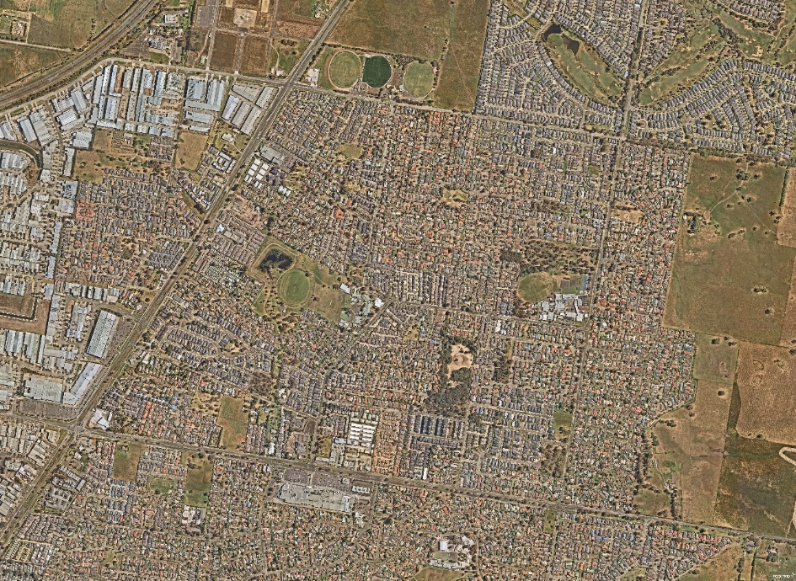
FRANKSTON-DANDENONG ROAD
MCCORMICKS ROAD
HALL ROAD
WEDGE ROAD
The LATM Process
The first step in the LATM process is the identification of traffic, safety, and access issues. This will be undertaken through the collection and analysis of data, together with information received from the community through a range of community engagement activities.
Following the identification of issues, a draft traffic management plan will be developed. Further community consultation will occur before the plan is finalised.
Community Participation
Community participation is essential in identifying existing traffic issues in your local area, and there are multiple ways to contribute to outcomes of this study. Please note that due to the ongoing restrictions and uncertainty associated with Covid-19, no face-to-face community engagement activities can be undertaken at this time.
All community members who have ideas, thoughts or concerns relating to traffic, road safety, pedestrian or cyclist issues, are strongly encouraged to get involved in one of the following ways:
- Provide your feedback and input via Social Pinpoint, a location based interactive mapping tool (available on both PC and mobile) prior to 8th February 2021.
Via the link here: frankston.mysocialpinpoint.com/McCormicksLATM (or use the QR code below).
- Complete the attached questionnaire and return it to Frankston City Council’s Engineering Services Department by 8th February 2021 using the enclosed ‘Reply Paid’ envelope or scanning and emailing to EngServices@frankston.vic.gov.au.
- Attend the Virtual Community Meeting, to be held via Zoom (a web-based meeting program) at 6:30pm on Wednesday 20th January 2021. At the meeting you will have the opportunity to provide your input on local street issues and suggestions for improvements.
- Nominate to be part of the Resident Traffic Committee comprised of interested residents. The group will meet up to 3 occasions and will be important in steering the study outcomes.
Registration is essential to nominate for the Resident Traffic Committee and to receive the web-based link to attend the virtual community meeting. Please email EngServices@frankston.vic.gov.au, by no later than Monday 18th January 2021 to register your interest, including the street in which you own or reside in your property.
Should you have any queries or require further information in relation to the above, please contact Ben Krastins (Ratio Consultants) on (03) 9329 3111, or Isuru Thilakaratne, Strategic Infrastructure Engineer at Frankston City Council on 1300 322 322.
Yours faithfully
Use your phone camera to scan the code and visit the Social Pinpoint engagement platform

Shekar Atla
ACTING MANAGER ENGINEERING SERVICES

